FOOLING OURSELVES

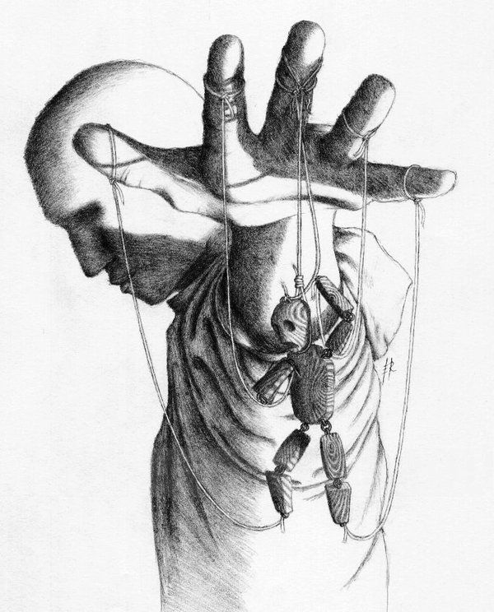

The 'sum of thinking' rules as one being with the ability to be everywhere at once - divided yet unified.

"The whole is more than the sum of parts." - Aristotle.

~

Isaac Newton F=ma describes a particle disappearing out of time at the speed of gravity.

The universe is the secondary result of this eternally recurring movement - a generator producing output.

We don't know this because we don't want to.

The will of man is the sum of 'who we think we are'; a nefarious consensus concocted in shadow.

We deliberately fool ourselves so that we will not have to answer personally.

Note: If you do a money deal with anyone, craftiness/intelligence will be in accord with their level of eternal awareness.

This is reflected in the wholesome forces of Islam and Christianity.

Note the popularity of the Pope.

In the 'wholesome world' of collective will, the eternally recurring universe becomes an anomaly not worth mentioning, yet it is happening with or without approval.

Ignorance of Eternity is no less manifest in the Sciences.

Ask any scientist/physicist if they accept Newton's F=ma as an eternally recurring event?

This is the litmus test for truth:

F=ma describes a quantum of energy.

The Quantum is the smallest particle of matter - everywhere at once.

Newton conceived it, Planck measured it, and Tesla invented a working model.

But we eat the icing and leave the cake.

Like waves on the ocean the enlightened are washed back and re-assimilated.

~

We are illusions manipulated by the master of thinking - one and the same.

We need to be found out.

We need to stop fooling ourselves.