**MASTER OF THE FIRE**

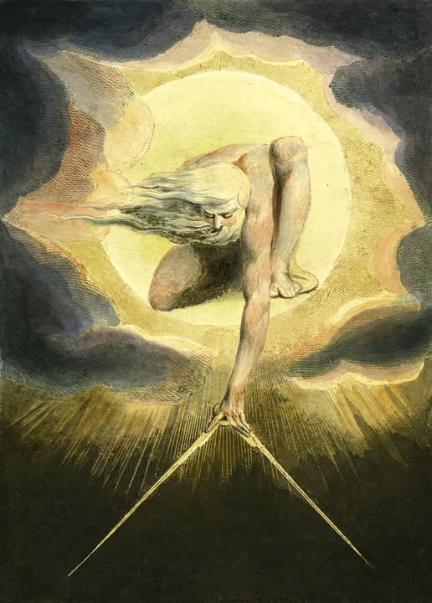

Newton’s Spark: Motion Beyond Time:

Isaac Newton’s equation F = ma was more than a scientific breakthrough—it was a revelation. It marked the moment when motion was no longer mystical, but measurable.

**Newton’s laws** gave structure to the cosmos, suggesting that even the stars obeyed a rhythm. But beneath the formula lay something deeper: a movement out of time, a spark that set the universe in motion. Newton didn’t just describe reality—he ignited it.

Centuries later, **Max Planck** uncovered a truth that shattered classical certainty. His quantum constant revealed that energy is not continuous but arrives in discrete packets—quanta.

This discovery birthed quantum mechanics, a science of probabilities and paradoxes. Planck’s constant became the heartbeat of a hidden world, one that defied logic and intuition. It was a divine number, difficult to unlearn, and impossible to ignore.

**Nikola Tesla** did not merely theorize the spark—he gave it form. His work with electricity and magnetism transformed the world, bringing the fire into our homes and cities. Tesla saw energy not just as power, but as vibration, frequency, and resonance.

He spoke of forces beyond comprehension, of patterns that echoed the cosmos itself. Tesla was a conductor of the spark, a visionary who glimpsed the fire’s true nature—and bowed to its mystery.

The fire is more than energy—it is singularity. It is everywhere at once, consuming all distinctions. “There is no other, we are one and the same.” This is not metaphor—it is quantum truth.

Entanglement, unity, recurrence: the fire is the collective sum of consciousness, the eternal twist that binds us all. Aristotle once said,

**“The whole is more than the sum of its parts.”**

Newton, Planck, and Tesla each revealed fragments of the spark, but none captured the fire in its entirety. The fire owns all. It is not reducible to equations or machines. It is the mystery that remains when all knowledge is exhausted.

To seek the spark is to confront the fire. To understand it is to awaken—not to control, but to recognize. The fire burns until the spark is found—not in formulas, but in awareness.

It is the master of all motion, all thought, all being. The test is not to dominate the fire, but to become part of it. To see it in ourselves, in others, in the cosmos. The spark is the beginning. The fire is the truth. And we, if we dare, are its witnesses.

**“The Tao is the fire that moves without burning, the spark that illuminates without consuming.”**