MUTINY

**“The whole is more than the sum of its parts."** - Aristotle.

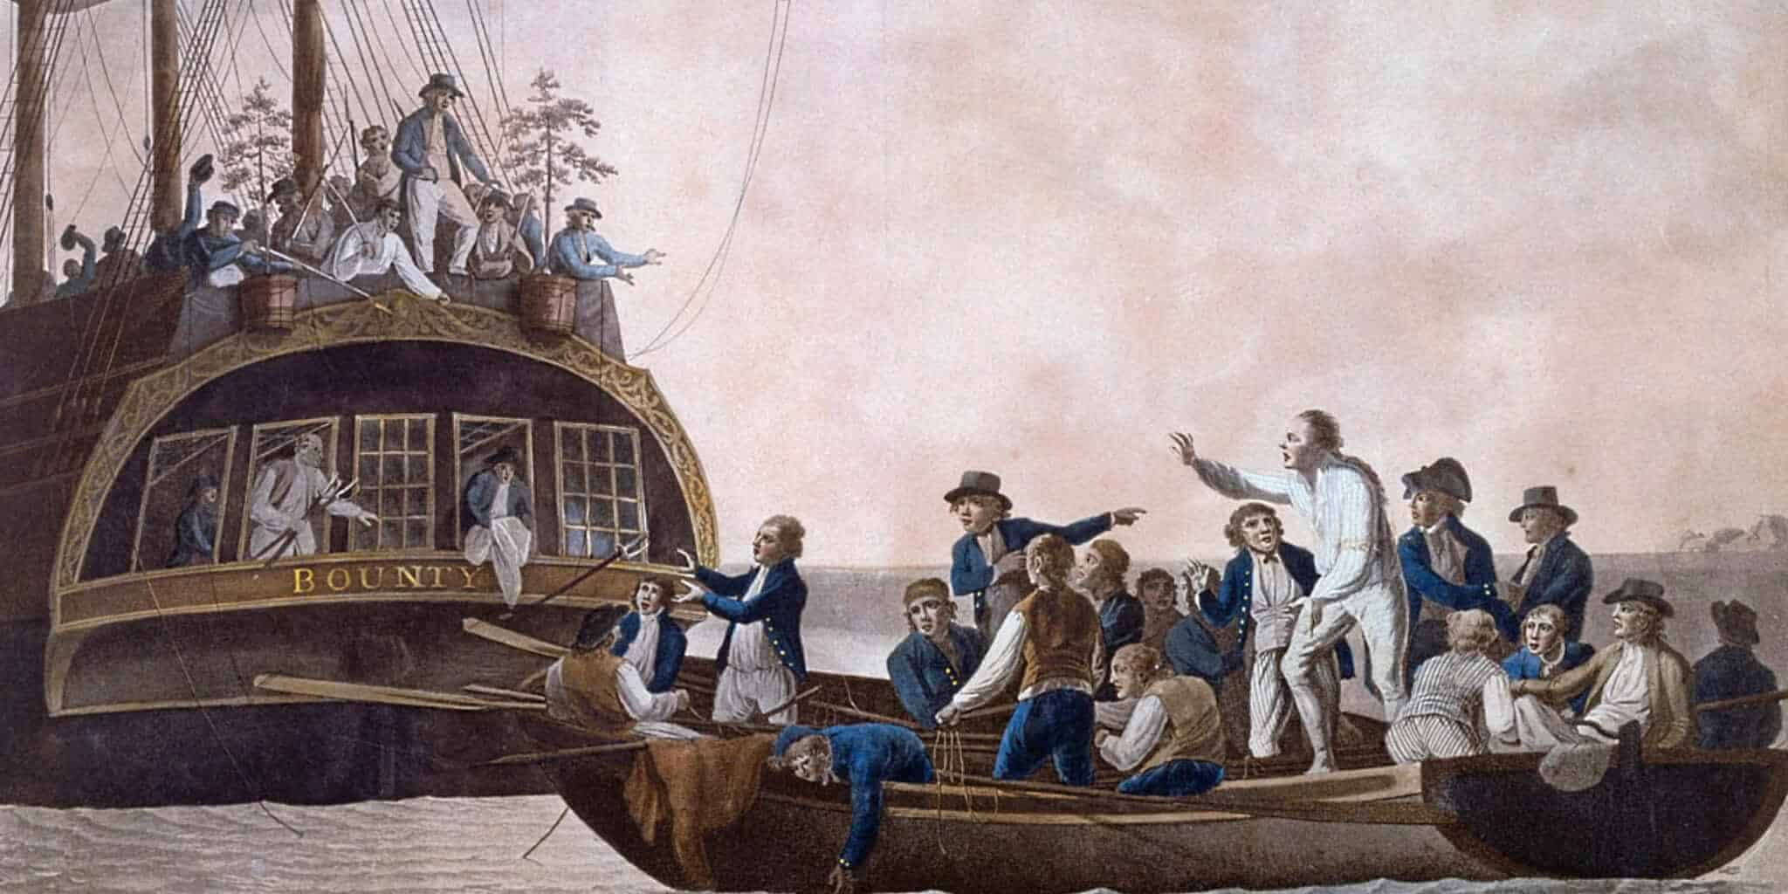

Energy began when, all as one, we twisted from Eternity.

A twist—not a break—for one cannot break from what one is.

The twist repeats, a spiral of motion, until the resistance that birthed it is reconciled.

Each recurrence of the twist is brand new— the beginning of time, the blank slate: la tabula rasa.

Resistance, omnipresent, watches itself grow. It multiplies, reflects, and soon forgets its purpose as the sum of its parts takes the wheel.

The phenomenon of collective will emerges— a test to recover the lost cause, now scattered, now steering the ship from every direction at once.

**“The significance which is in unity is an eternal wonder.”** — Rabindranath Tagore.