O

ONE IS ALL

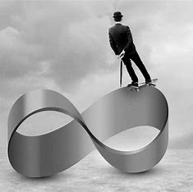

**“You are not a drop in the ocean. You are the entire ocean in a drop.”** — Rumi

One is all means all things at once - without energy. This is unconditional love/Eternity.

We are not separate. We are not many. We are the One—twisted into movement, mistaken for thought, and scattered across illusions we call reality.

All as one, we are a twisted perception growing like a weed, taking over the universe as we create it.

This beast of our discontent is ANTITHESIS.

Despotism does not arise from chaos—it is the echo of collective thought, the repetition of a single resistance masquerading as progress.

We do not suffer because we are divided; we suffer because we have forgotten that division is illusion.

Thought is not freedom. It is the first twist—the quantum pulse that birthed the universe and every false reference point we cling to.

Planck’s constant marks the measure of illusion, not the measure of truth. It is the circle collapsing inward at the speed of gravity.

We direct the universe by proof, and in doing so, we fool ourselves into believing we are real. But the sum of 'who we think we are' knows better. We know better! And yet, we remain silent, so long as our plates are full.

Justice begins when we dissolve the illusion of separation. **“Only he can be just who is able to put himself in the position of others.”**

Gurdjieff’s “he” is not a man—it is the pulse behind every face, every cry, every silence. 'He' is awareness.

We must reclaim the throne not above the stars, but within the collapse. Not by ascending, but by remembering. The mount of assembly is not a place—it is the moment we choose to see through the illusion and act from unity.

Let this be our declaration: We are the One. We are the pulse. We are the justice that sees itself in all things.

**“People like us, who believe in physics, know that the distinction between past, present, and future is only a stubbornly persistent illusion.”** — Albert Einstein.