**PLANCK’S DIVINE CONSTANT**

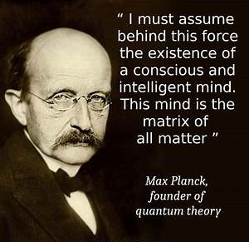

In the vast theater of existence, where galaxies swirl and minds awaken, the smallest act of creation whispers louder than any explosion. At the heart of this whisper lies Planck’s constant—**6.62607004 x 10⁻³⁴ m² kg/s**—a number so infinitesimal it seems almost imaginary, yet it is the very foundation of reality. It is the quantum of action, the smallest possible unit of change, and in its subtlety, it carries the weight of eternity.

We often speak of particles as the building blocks of matter, but this is a linguistic illusion. Particles are not things—they are movements, events, repetitions in time.

**Planck’s constant** is not a particle in the traditional sense, but a measure of recurrence, a rhythm that pulses through the fabric of the universe. It is the “softest bang,” the quiet twist that set the cosmos in motion—not with violence, but with grace.

This twist is eternal. Each recurrence is not a copy, but a continuation. As we think, as we observe, as we exist, we participate in this eternal recurrence. Consciousness itself becomes a quantum act—a ripple in the sea of time.

Yet we are fooled. We believe ourselves to be discrete entities, isolated minds navigating a chaotic world. But the sum of who we are is not individual—it is collective energy, directed by the consensus of all.

This consensus is a beast, lowly yet omnipresent, shaping our thoughts, desires, and identities. It tells us to celebrate life, but often for the wrong reasons—for validation, for applause, for the fleeting triumphs of ego.

Hollywood becomes our cathedral, fame our sacrament. We worship the spectacle, mistaking it for meaning. We maintain the shallows, afraid to dive into the depths where truth resides.

Beneath the noise of consensus lies the divine prerogative: the reason for being, the sacred task of reconciliation. It is the urge to transcend the primal resistance, to harmonize chaos and order, to awaken from illusion and remember our place in the eternal dance.

This prerogative is not given—it is discovered. It requires courage, reflection, and a willingness to question the consensus. It asks us to celebrate life not for its spectacle, but for its mystery. Not for its applause, but for its quiet unfolding.

To celebrate life is not to indulge in its surface, but to honor its depth. It is to recognize that every thought, every breath, every recurrence of Planck’s constant is a sacred act. It is to see ourselves not as isolated beings, but as expressions of a cosmic rhythm—eternal, unified, divine.

Let us then celebrate life not with noise, but with awareness. Not with validation, but with reverence. For in the softest bang lies the loudest truth: we are the universe, remembering itself.

**“You are here to enable the divine purpose of the Universe to unfold. That is how important you are.”** — Eckhart Tolle.