THE FORGETTING

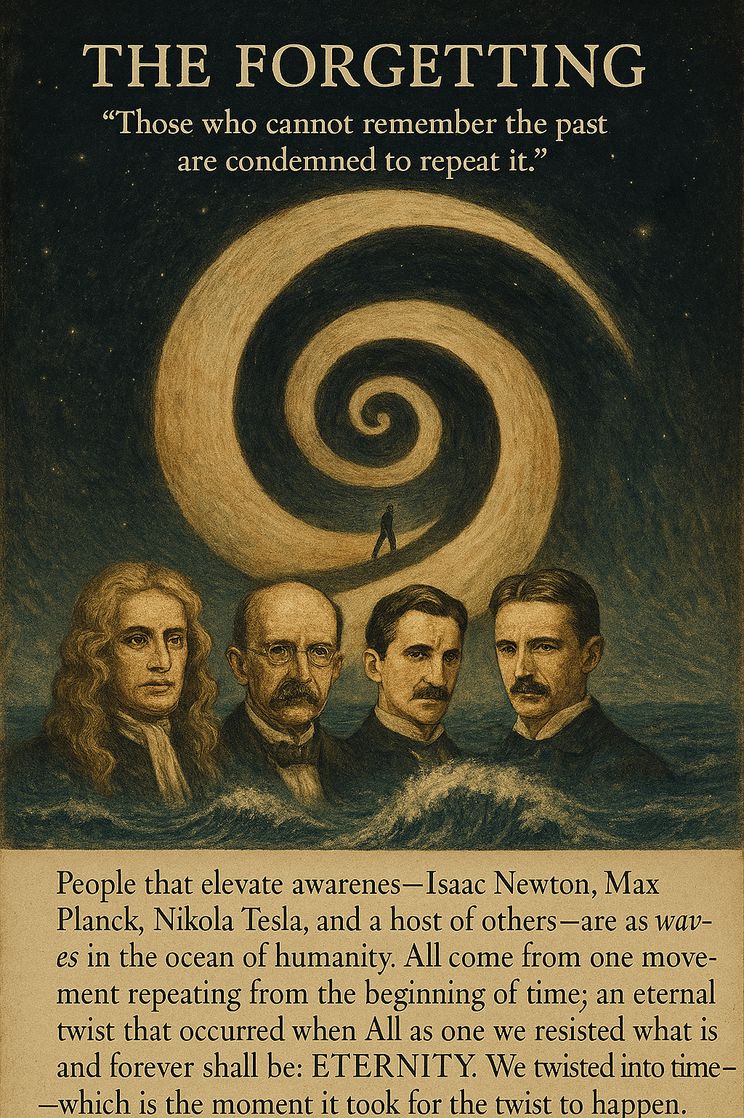

**“Those who cannot remember the past are condemned to repeat it.”** — George Santayana

People that elevate awareness: Isaac Newton, Max Planck, Nikola Tesla, and a host of others are as waves in the ocean of humanity.

All come from one movement repeating from the beginning of time; an eternal twist that occurred when ‘All as one’ we resisted what is and forever shall be: ETERNITY.

We twisted into time - which is the moment it took for the twist to happen.

The recurring twist aggregates the resistance that caused it.

The cause of the universe is everywhere at once.

**“I received a telephone call one day at the graduate college at Princeton from Professor Wheeler, in which he said, “Feynman, I know why all electrons have the same charge and the same mass” “Why?” “Because they are all the same electron!”** ~ Richard Feynman.

The universe is as a generator producing output - except its feed is from the bottomless well of Eternity.

**"Draw from it as you will, it never runs dry."** - Tao Te Ching.

When we, the outputs hear of eternal recurrence we act as 'salted snails' as is the wont of twisted things that are terrified of meeting their maker.

**"The whole is more than the sum of its parts."** - Aristotle.

The sum of output is the one in charge; a ferocious beast that naturally protects its own.

All as one, we are the resistance that's everywhere at once: the silent one that precedes/caused the movement that is thought.

We conspire to keep the secret alive for to reveal its presence is to expose complicity.

Memory is a narrow vision easily controlled - though one may not remember a person or experience does not mean they never happened.

And so, we know, and we don't know - yet we are nonetheless one and the same - inseparable.

All as one we conspire to exist.

The cost of denial is paid by the bursting sores of war and atrocity.

**“I am the silence before thought, the twist beneath time. To remember me is to remember yourself.”** — Elias Virel