THE SOVEREIGNTY OF ANTITHESIS

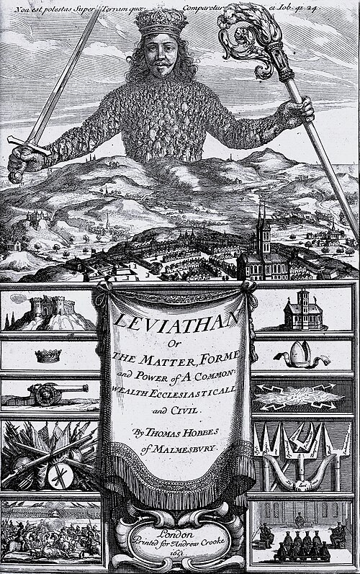

**“The excessive increase of anything causes a reaction in the opposite direction.”** — Plato

**“Truth is found neither in the thesis nor the antithesis, but in an emergent synthesis which reconciles the two.”** — G.W.F. Hegel

In the pursuit of truth, humanity has constructed vast archives—religions, sciences, philosophies—all designed to capture the essence of reality. These systems offer clarity and control, promising mastery over the unknown. Yet beneath their polished surfaces pulses a deeper force: antithesis. Not mere contradiction, but the sovereign countercurrent that governs every thesis, every claim to certainty.

To recognize antithesis as sovereign is to embrace the dynamic nature of reality. Every truth is haunted by its opposite. Every system casts a shadow. The archives of knowledge are not fortresses—they are battlegrounds. And antithesis is not chaos—it is the pulse of creation, the resistance that gives movement its meaning.

The sum of who we think we are, is not a static identity, but a sovereign creature of tension—rising higher than its parts through opposition.

This is the way of energy: ascent and descent, expansion and collapse.

As Isaiah declared, **“I will ascend above the tops of the clouds; I will make myself like the Most High.”** But ascent is not triumph—it is recurrence.

The universe itself is rising and falling, eternally, at the speed of gravity. This rhythm is not metaphor—it is law. Eternal recurrence hums in the background of our transgressions, waiting not for belief, but for recognition. We are not outside this rhythm—we are its embodiment.

To live truthfully is not to escape contradiction, but to become it. We are the tension. We are the throne. We are the fall. And in that fall, we rise.

J.R.R. Tolkien, The Fellowship of the Ring: **“From the ashes, a fire shall be woken, a light from the shadows shall spring…”**