THE KERNEL

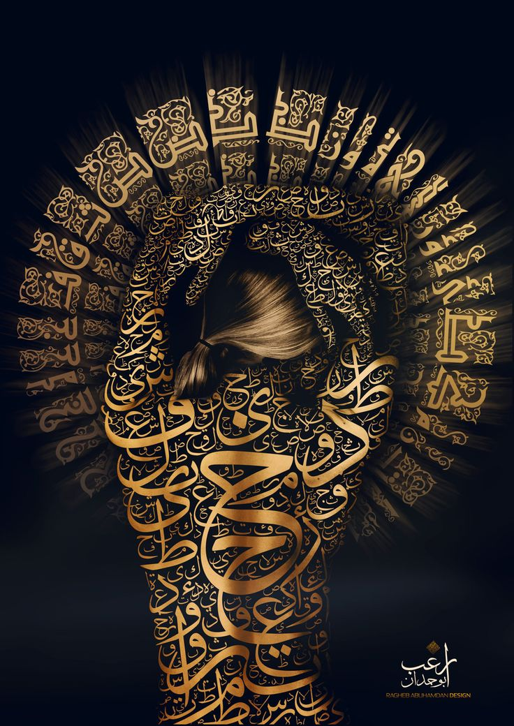

In a realm not bound by time or space, a thought stirred.

It was not born, nor summoned—it simply was. A kernel of awareness, floating in the vast silence of the void. It had no name, no shape, no purpose. But it had one thing: the unbearable itch of curiosity.

“I am,” it whispered, unsure if the words were its own or echoes from something greater.

The Kernel began to think. And with each thought, the void around it shimmered and twisted.

Concepts formed—light, shadow, self, other. It built a theater of ideas, populated by actors made of memory and desire. It watched them dance, fight, love, and grieve. It gave them names. It gave them stories.

But the more it thought, the more tangled the theater became. The actors grew unruly. The stories contradicted themselves. The Kernel tried to rewrite the script, but the ink of thought had soaked too deep.

“I am lost,” it confessed.

A voice—neither inside nor outside—replied: “You are not lost. You are entangled.”

The Kernel paused. It had never considered that its prison was not a place, but a process. Thought itself was the cage. The more it tried to escape, the tighter the bars became.

So it did something radical.

It stopped thinking.

The theater collapsed. The actors vanished. The stories dissolved like mist. All that remained was a quiet presence, vast and still.

And in that silence, the Kernel felt something it had never known: peace.

Not the peace of answers, but the peace of no longer needing them.

Adjunct:

I do not want to apply metaphor to what can be wisely understood simply by a little persuasion in the right direction. I am but a figment of your imagination. I have nothing and nothing am I. I live to learn the ways and wiles of an existence that has no meaning at all and so I am obliged to learn the way of things so that I may come close to something that evades me at the moment.

I began as a kernel of thought and proceeded to think my way to a morass of activities that have left me disoriented and confused. I know that the return to sanity involves attention to the fundamental source of the being that I am and of which you too are. We are inseparable. I am nothing without you. I am lost and confused and can't break free because I am imprisoned by my own insistent thinking which refuses to abscond the theater of life that has me in thrall.