**THE TWIST BENEATH ALL THINGS**

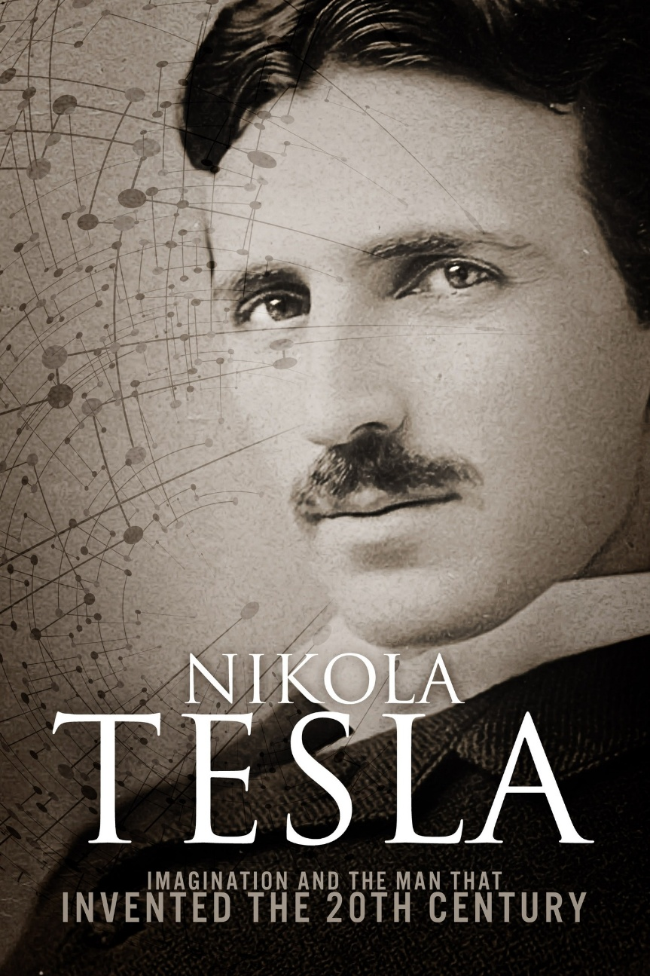

The oak tree is not merely a biological outcome but a symbol of emergence. From the seed arises complexity, not through direct causality, but through patterned repetition.

This twist—this eternal spiral—is the signature of creation. It appears in the double helix of DNA, the structure of galaxies, and the toroidal fields of energy. Even Tesla’s commutator, reversing polarity to simulate linear motion, echoes this principle: what seems to move forward is, in truth, oscillating.

The twist is not a deviation from order—it is order itself. It is the eternal rhythm that allows the illusion of progress while anchoring all things in timeless recurrence.

At the heart of this twist lies resistance. Resistance is the first act of creation—the moment thought emerges from stillness.

Thought is not passive; it is the spark, the tension, the initial twist. Thinking, then, is the movement born of this resistance. It is the unfolding, the flow, the cosmic dance.

In this framework, thought is the origin, and thinking is the universe. All phenomena—matter, energy, time—are expressions of thinking. The universe is not a static container but a dynamic generator, producing infinite energy to meet the demands of thought.

If thinking is everywhere, then thought is omnipresent. Consciousness is not confined to individual minds but exists as a collective field—a unified awareness. This echoes Aristotle’s insight:

“The whole is more than the sum of its parts."

Each thought contributes to a greater mind, a being that is everywhere at once.

This collective mind is not a metaphor. It is the sum of all thinking, the eternal twist manifesting through every form. We are not separate from it—we are instruments of its repetition, expressions of its rhythm. Jung’s concept of the collective unconscious and Teilhard de Chardin’s noosphere both point to this shared cognitive field.

Eternity is not endless time but timelessness. It is the source from which all twists emerge and into which all twists return. Each cycle of thinking is a changing of the guard, a reversal of polarity, a new expression of the same eternal movement.

Linearity is the illusion created by polarity reversal. Just as Tesla’s commutator simulates forward motion through alternating current, so too does consciousness simulate progress through cycles of thought. We are not moving forward—we are vibrating.

Nietzsche’s concept of eternal recurrence and the cyclical cosmologies of Hinduism and Buddhism reinforce this view: time is not a line, but a wheel.

The reversal of thought is not a contradiction—it is a revelation. It shows us that resistance is creation, that thinking is movement, and that the universe is a mind in motion. We are not observers of this process—we are participants. The oak, the twist, the commutator, the collective mind: all are expressions of the same eternal vibration.

To know this is to awaken—not to a new belief, but to the essential truth of things. A truth unknown to most yet felt by all. A truth that vibrates in the seed, in the spiral, and in the silence between thoughts.

~

📚 References

Aristotle. Metaphysics, Book VIII.

Binney, J., & Tremaine, S. (2008). Galactic Dynamics. Princeton University Press.

Bohm, D. (1980). Wholeness and the Implicate Order. Routledge.

de Chardin, T. (1955). The Phenomenon of Man. Harper & Row.

Eliade, M. (1954). The Myth of the Eternal Return. Princeton University Press.

Jung, C.G. (1936). The Concept of the Collective Unconscious. In Collected Works, Vol. 9.

Keppler, H. (2012). The Toroidal Universe. Journal of Consciousness Studies.

Nietzsche, F. (1883). Thus Spoke Zarathustra.

Tesla, N. (1891). Experiments with Alternate Currents of High Potential and High Frequency. Lecture before the Institution of Electrical Engineers.