**“It is important to realize that in physics today, we have no knowledge of what energy is.”** ~ Richard Feynman (1918-1988), Nobel Prize winner.

**ENERGY IS A POINT OF VIEW**

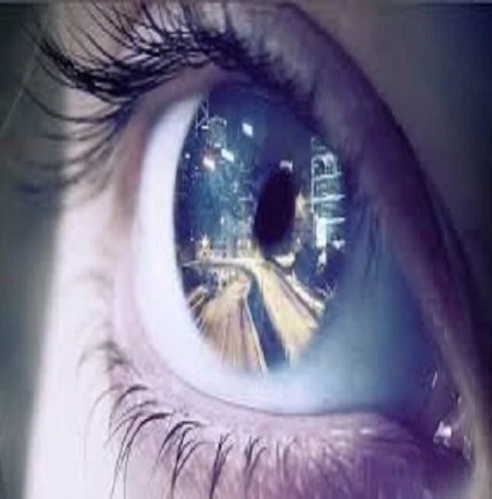

Thought is the eternal resistance that caused a point of view.

It was the smallest particle; 'all as one' twisting the eternal one to create energy.

The first energy is a construct with positive/negative and the tension that keeps them apart.

It is a unit of force (Newton) that lasted for the least time before it resumed Eternity.

Be it noted that the spin-out or twist was not disconnection but a point of view come to life.

Isaac Newton defined the movement as **F=ma.**

Max Planck established its value as **6.62607004 x 10⁻³⁴ m² kg seconds (**Planck's constant).

Nikola Tesla recognized it as a recurring source of 'free energy' (**eternal recurrence**).

And so, it goes!