**“It is important to realize that in physics today, we have no knowledge of what energy is.”** ~ Richard Feynman (1918-1988), Nobel Prize winner.

**ENERGY IS A POINT OF VIEW**

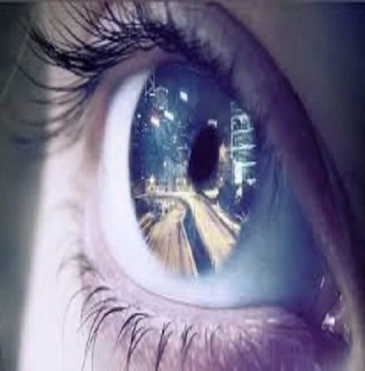

Thought is the resistance that caused a point of view.

It was the smallest particle; 'all as one' twisting Eternity to create energy.

The first energy is a construct of positive/negative and the tension to keep them apart.

It is a unit of force that lasted for the least time before it resumed Eternity. (Newton)

Be it noted that the spin-out or twist was not disconnection but a point of view come to life.

Isaac Newton defined the movement as **F=ma**.

Max Planck established its value as **6.62607004 x 10⁻³⁴ m² kg seconds** (Planck's constant).

Nikola Tesla recognized it as a recurring source of 'free energy' (**eternal recurrence**).

And so, it goes!