**EVERYWHERE AT ONCE**

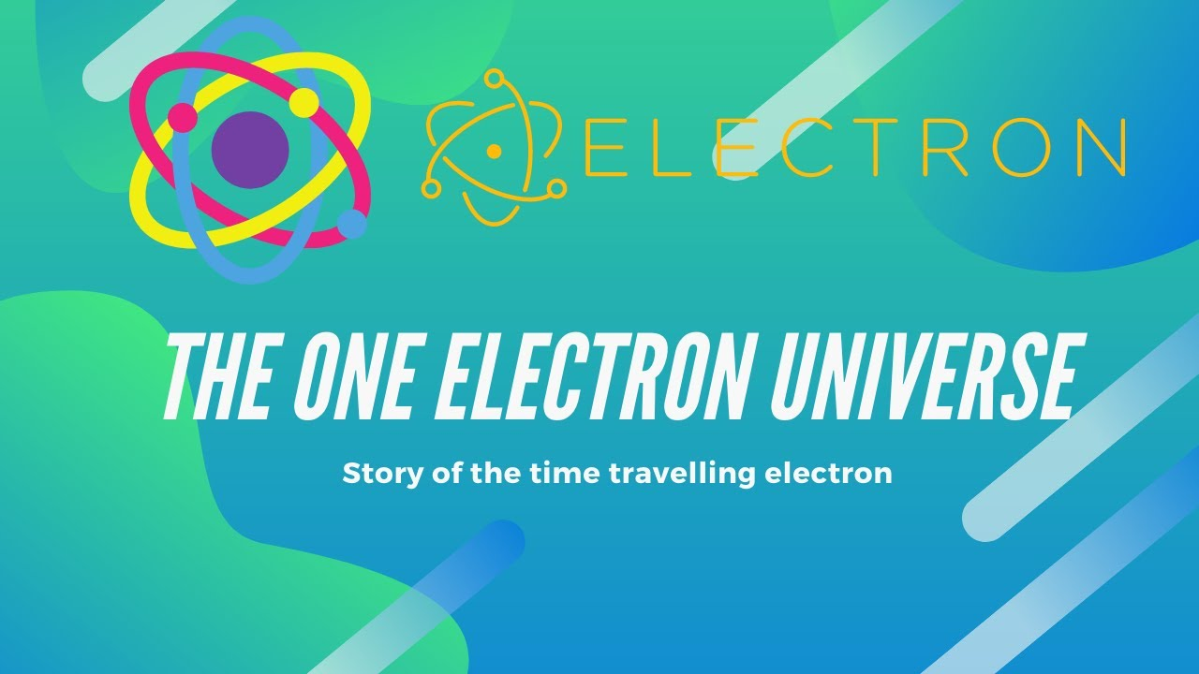

Thought is the silent precursor, the originator of species. We are the species of thought.

**“According to a theory proposed by theoretical physicist John Wheeler, who outlined his thoughts in a conversation with fellow physicist Richard Feynman there is only one electron – it just looks like there are a lot more because it is moving forward and backward in time.”**

All, as one, we resisted **One is all** and turned ETERNITY inside out for an instant of time that accumulates as we think. This is how we generate the universe.

'All as one' we are thought, and as we think we reduce.

**"Thought itself is an actual process of movement.”** - David Bohm.

'All as one' we are everywhere at once within the reductive species that emerge.

As evolution proceeds, 'all as one' we reduce to the height of ignorance.

**“I will ascend to the heavens; I will raise my throne above the stars of God; I will sit enthroned on the mount of assembly, on the utmost heights of Mount Zaphon. I will ascend above the tops of the clouds; I will make myself like the Most High.”** – Isaah 14:13-14.

'All as one' we reduce to the height of ignorance with dominion over a vast progeny. We mistake control for clarity.

**“The whole is more than the sum of its parts**.” - Aristotle.

This is the challenge to overcome.

**“Not to know it is blindness that works evil.”** - Tao te Ching.

“Thought is the silent precursor, the originator of species. We are the species of thought.”