**FEEDING FROM ETERNTY**

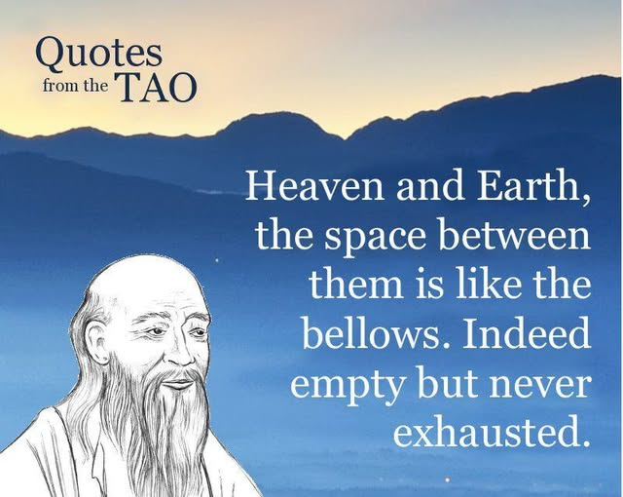

One is All.

“I know why all electrons have the same charge and mass… because they are all the same electron.” —John Wheeler to Richard Feynman

The resistance that caused Eternity—One—to turn inside out for an instant is the beguiling presence Bohm might call active information—a field of implicate order that exists everywhere at once, intensifying its loss by repetition. This is not entropy, but emotional recursion: the ache of a twist that never breaks.

“Thought itself is an actual process of movement.” —David Bohm

The state of reduction is the sum of its thinking in any moment. Reduction is not simplification—it is the collapse of possibility into form. Each thought is a twist in the field, a momentary knot in the eternal braid.

All is motion. All is emotional. Energy, as Feynman confessed, is undefined. It is not a substance but a perspective—a point of view that moves.

The mechanical structure of the emerging universe is described not by abstraction, but by a hairdryer—or any generator. Faraday’s coil. Tesla’s alternating current. The twist of wire between poles. The breath of motion.

“Every living being is an engine geared to the wheelwork of the universe.” —Nikola Tesla

The difference between the universal generator and a hairdryer is this: The universe recurs eternally. Its energy is free.

"Draw from it as you will, it never run's dry.' - Tao Te Ching.

Tesla saw through Einstein’s relativity, calling it “a beggar clothed in purple.” He favored motion over abstraction, recurrence over illusion.

The sum of who we think we are feeds from the breast of Eternity. Like babes we feed. And like babes we care only to feed. But we are grown men and women—confused, dangerous—because we haven’t advanced beyond the immediacy of desire and need.

We do not question, so long as our feed is guaranteed. And it is guaranteed—for Eternity cannot deny its own.

“Not to know it is blindness that works evil.” —Tao Te Ching

It’s time to grow up before the garden goes dry.

“Eternity is the source of Energy.” —Nikola Tesla