HEAVENLY SCROLL

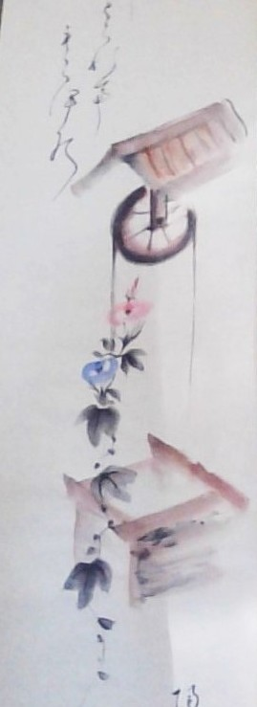

**"Eternity is the source of energy."** - Nikola tesla.

I ordered this calligraphy online and the following note was included with the shipment.

*Mr. Kitt  
Enjoy/treasure this genuine hand-painted scroll by Mrs. Robinson my Japanese/American 'bride' who taught this art at Merced College here in Calif.. Best, Lin Van.*

The wheelbarrow indicates the bottomless well of Eternity feeding/turning a wheel that delivers energy to the universe, all contained in boxes of their own thinking to be opened and grown back to the source.

~

1) The Eternal return of the wheel is indicated by Isaac newton's **F=ma**.

2) The energy of the wheel is **Planck's constant.** (Quantum)

3) The eternally recurring wheel was utilized by Nikola tesla to produce **alternating current.**

**"'Draw from it as you will, it never runs dry."** - Tao Te Ching.