LOST IN THINKING

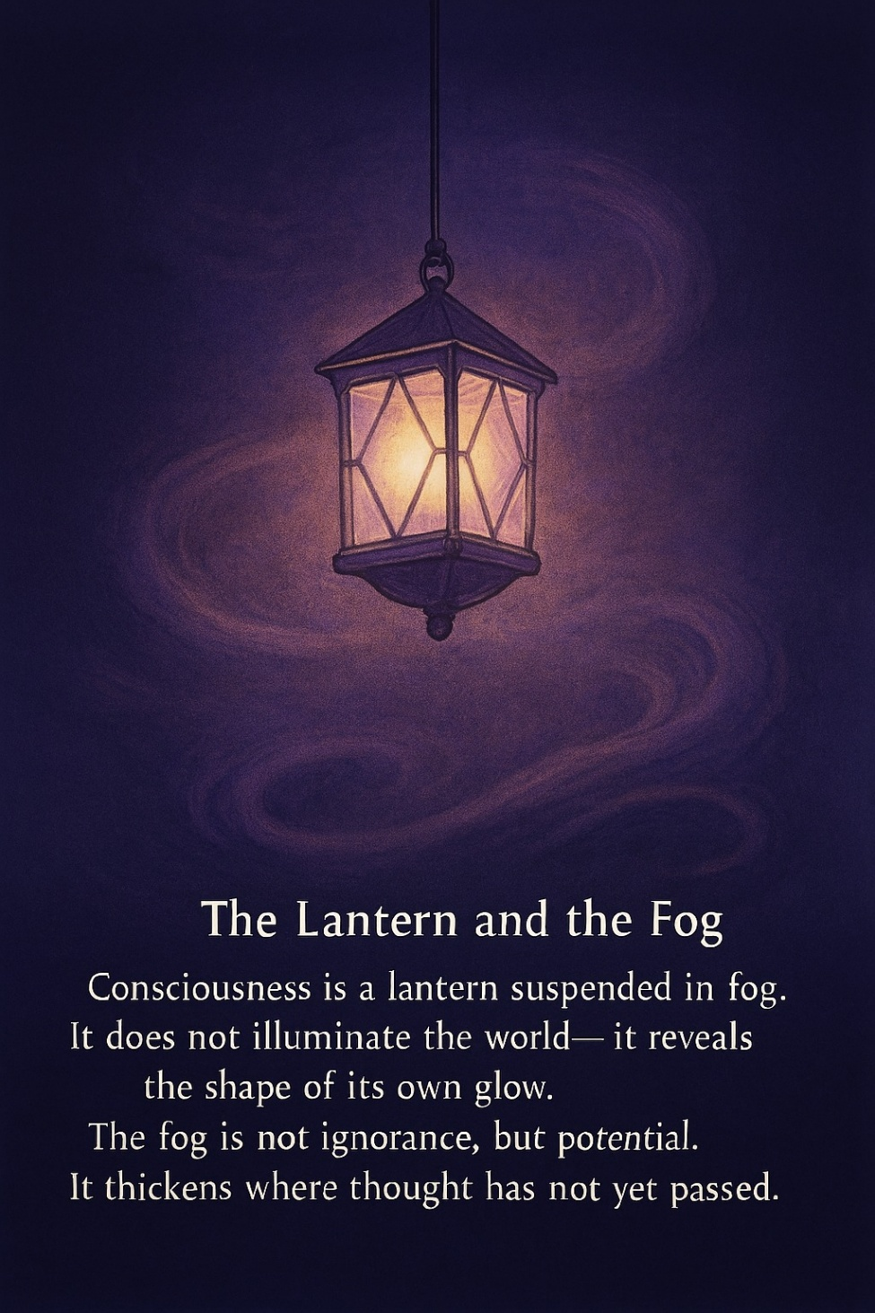

The first act of any engine—be it mechanical or cosmic—is to return its initiating spark to source. In 1831, Faraday’s coil spun between magnetic poles, generating electricity that was stored in chemical units. But Tesla, seeing inefficiency in storage, transmitted energy directly as alternating current—pure reciprocity in motion. So too, the universe: a self-charging system of infinite efficiency.

**"Every living being is an engine geared to the wheelwork of the universe."** —Nikola Tesla

All as one, we opened a gate—a discreet pulse of energy, enough to ignite the universal engine. Then, as with Tesla’s AC, the energy returned—not stored but transmitted. This is absolute reciprocation. A perfect balance of power.

The infinite twist was caused by All as one—a thought. Not metaphor, but movement.

**"Thought itself is an actual process of movement."** —David Bohm

Bohm taught that thought is not static—it folds, unfolds, and participates in shaping reality. As thought ‘thinks,’ the gateway opens and closes, fulfilling the needs of thinking—one twist at a time.

The universe is All as one, twisting until its thinking discovers thought. This is not emergence—it is proprioception.

**"There is no activism. There is only proprioception of thought."** —David Bohm

Thought becoming aware of its own movement, no longer projecting outward but folding inward.

**"The whole is more than the sum of its parts."** —Aristotle, Metaphysics

This unity is not additive—it is integrative. The twist is not a sequence, but a singularity.

Finally reconciled, thought, no longer roams the eons of time. It does not begin again. It does not twist anew. It rests—not in inertia, but in knowing.

**"The five colors blind the eye... the sage attends to the belly, not to what he sees."** —Lao Tzu, Tao Te Ching, Chapter 12

The movement ceases because the mover is known. And in that knowing, time folds inward. Not to repeat, but to remain.

**“To the mind that is still, the whole universe surrenders.”** — Lao Tzu, Tao Te Ching.