**NOUS**

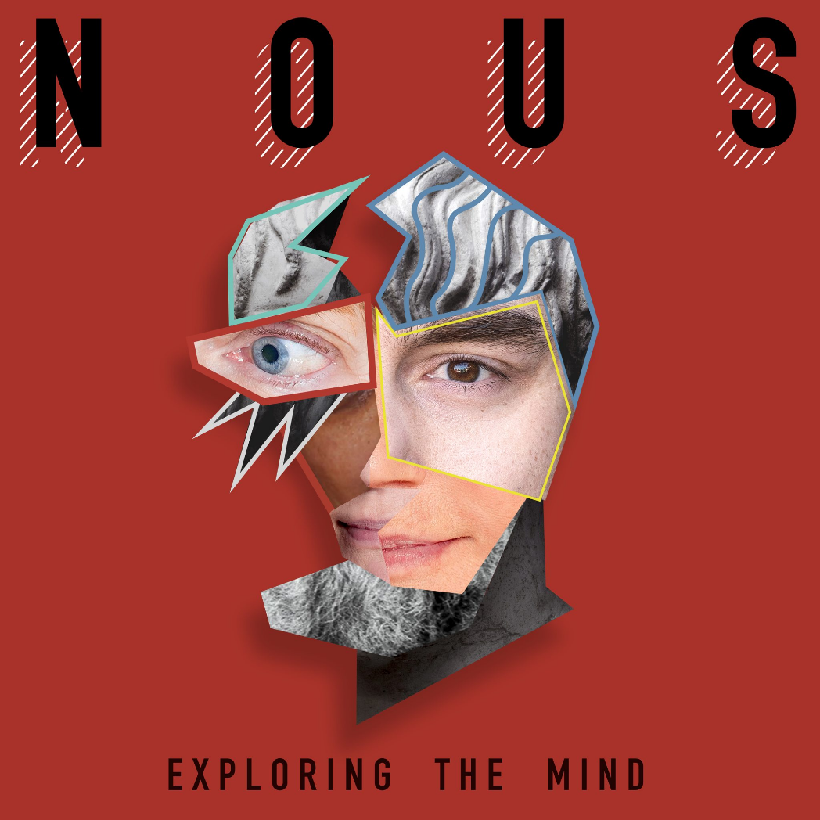

Merriam-Webster: an intelligent purposive principle of the world.

**"I think: therefore I am."** - Descartes.

Each person is the changing sum of his/her thinking, and the sum of thinking is the mind of thinking as a whole. THIS IS NOUS.

**“The total number of minds in the universe is one.”** – Erwin Schrodinger.

The universal collective has divine purpose:

As subjective contributors we are unaware that objective cohesion is a natural occurrence representing the true measure of how we present ourselves as one being.

All is one no matter how we talk ourselves out of it and all as one is where we stand in terms of it.

We are here to solve ourselves and the objective tabulation cannot lie.

**“Education is the kindling of a flame, not the filling of a vessel.** – Socrates