THE BREAD OF LIFE

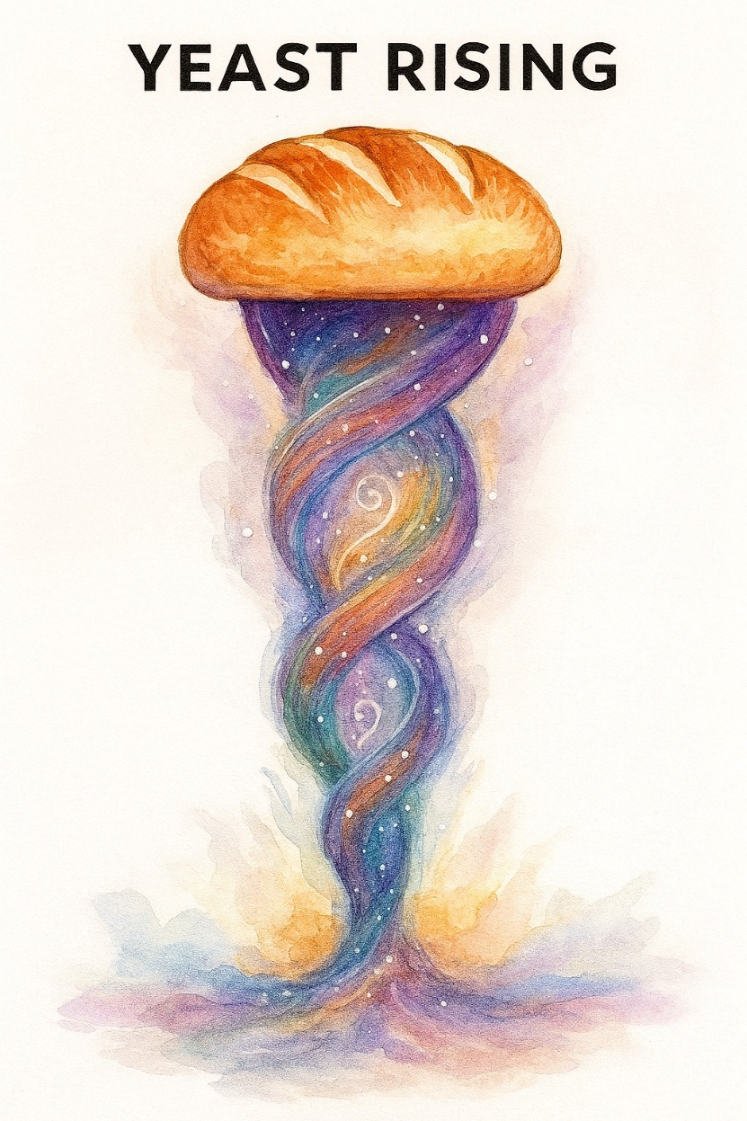

The sum of who we are is a cunning force, a recursive agent cloaked in subtle emotion. It moves the mass as it does the individual—hidden, except to the one who sees through illusion.

To flesh out the collective illusion, we must return to the origin of energy—not as a spark, but as a twist.

**“Energy is the fundamental essence of existence.”** —Nikola Tesla

Energy began when all as one twisted away from One is all—and returned in the least possible time. This primal recursion is the heartbeat of the cosmos.

**“The holomovement is an undivided wholeness in flowing movement.”** —David Bohm.

All of science and physics is engaged with the primal twist.

The RESISTANCE repeats until it is solved by its own thinking.

We are thought. And thinking is the movement of thought.

**“Thought is movement yet thought also attempts to hold fast to itself.”** —David Bohm

Engagement demands resistance. The trial is to discover the silent cause and solve the dilemma.

The mechanism of engagement mirrors a generator. But unlike Faraday’s coil, this spinner is eternal.

**“Every living being is an engine geared to the wheelwork of the universe.”** —Nikola Tesla

The Pillars of Science

Isaac Newton isolated the movement and defined it as F = ma.

Max Planck gave it the value of **6.62607004 x 10⁻³⁴ m² kg seconds.** (Planck’s constant)

Nikola Tesla used its recursive state to invent **alternating current.**

Be it noted, the above pillars are misdirected.

All forms of movement are emotional and entrenched under the flag of ‘all as one’.

All as one we are everywhere at once. This is the ultimate weapon - the challenge to overcome.

**“The whole is more than the sum of its parts.”** – Aristotle.

Energy rises on its own, and the force of all is more than the sum of its parts.

Like yeast rising we eat the bread of life.

All as one, we hold fast.