THE COLLECTIVE
"A lot of thinking without wisdom is extreme suffering." - Buddha.

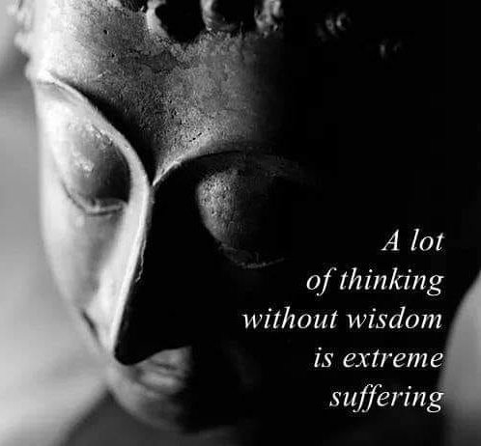

“The Monster of Time is the sum of our own thinking. As one.”
Every human being is under the wheel of its own vehicle, but we know it not, for everyone has a different view of the vehicles they drive.
The primal vehicle is a movement twisting in/out of Eternity. The universe of vehicles are archetypes of this prototype - same but different!
Eternal re-occurrence spins the universe to life. The beginning movement is thought, and we are the thinking of thought - one and the same - one with a twist.
Isaac Newton framed the movement as F=ma.
F=ma indicates a movement travelling out of time.
Newton knew we were not requiring a simple answer, and so he invented Calculus.
Two generations later Maleva Maric (Einstein's first wife) used calculus to build a scaffold for the movement out of time.
This was the original Theory of Relativity. - which proposes the universe as the secondary result of the same movement flashing in/out of Eternity without cost -
Each spark of energy brand new from the beginning of time.
The sum of sparks: the universe. - thought and its thinking - in flux.
Max Planck gave us the measure of the spark, and it is known as Planck's Constant. (6.62607004 x 10⁻³⁴ m² kg seconds)
Nikola Tesla envisioned the eternally recurring spark of energy and gave us 'alternating current'.
The above are the simple facts of life that all should know by now, but don''!
The reason for this is 'the sum of thinking’ has a mind of its own.
This is the COLLECTIVE UNCONSCIOUS. - our challenge to overcome.
“frightening thought that man also has a shadow side to him, consisting not just of little weaknesses- and foibles, but of a positively demonic dynamism. The individual seldom knows anything of this; to him, as an individual, it is incredible that he should ever in any circumstances go beyond himself. But let these harmless creatures form a mass, and there emerges a raging monster; and each individual is only one tiny cell in the monster’s body, so that for better or worse he must accompany it on its bloody rampages and even assist it to the utmost. Having a dark suspicion of these grim possibilities, man turns a blind eye to the shadow-side of human nature. Blindly he strives against the salutary dogma of original sin, which is yet so prodigiously true. Yes, he even hesitates to admit the conflict of which he is so painfully aware.”
~ Carl Jung, “On the Psychology of the Unconscious”.

