⚡ THE ENERGY CHALLENGE

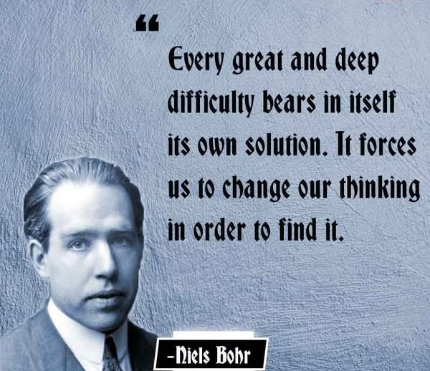

There is but one eternal movement—and we are all part and parcel.
This movement was born of resistance. And because Eternity means ONE is all, “all as one” is the resistance. The movement is a twist—an unwinding spiral—that continues until resistance is released.
This is what we are all attempting no matter how we twist out of shape.
The eternally recurring spinner provides energy—one bit at a time—to support our efforts to release resistance. But there is a catch:
The sum of who we think we are, is always at the pinnacle of the energy hierarchy, directing all that it is with impunity.
As Aristotle said,
“The whole is more than the sum of its parts.”
This is humanity’s challenge to overcome.
🌟 The Good News
Isaac Newton discovered the disappearing movement. His law of motion, F = ma, describes a universe in motion—vanishing into time. As Mileva Marić, Einstein’s first wife, once used Newton’s calculus to “build a stairway to heaven,” the movement itself was already disappearing out of time.
Max Planck measured it. He revealed that energy is not continuous but quantized—delivered in discrete packets. This was the first glimpse of the spinner’s rhythm: energy released bit by bit, not in bulk.
Nikola Tesla gave it practical application. He bypassed the need for storage and transmitted energy directly -pure flow, no residue. As Tesla said,
“Every living being is an engine geared to the wheelwork of the universe.”
Yet the information is distorted. Einstein’s “space-time” was a spanner in the works—a metaphysical fog that dazzled and confused. Tesla saw through it, calling it “a beggar clothed in purple whom ignorant people take for a king.” Szilard felt the weight. Truman used it. Marić was made obscure.
The twist continues. Eternal recurrence is happening—whether we agree or not. And as the Tao Te Ching warns:
“Not to know it is blindness that works evil.”

