THE HEART OF DARKNESS

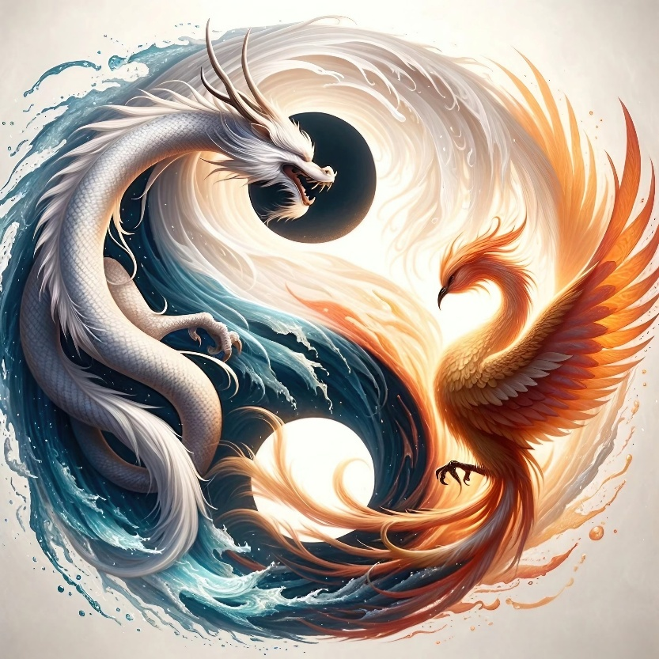

The universe is the secondary result of one vibrating movement.

This is as any common generator except the spinner is eternally recurring.

The movement began when 'all as one' we became a point of view; this required a movement/twist - thus, energy began.

The point of view was a flash of time that desired to know itself. The spinner cycles to produce the universe for this purpose.

Few are aware that all is gathering back to eternity at the speed of gravity. (Isaac Newton's F=ma)

Repetition builds time, and the sum of who we think we are, is protected within the folds of time.

**"The whole is more than the sum of its parts."**

- Aristotle.

The sum of who we think we are forms a protective veil; a dragon comes forth setting fire to those who challenge.

I have touched the heart of this darkness and know it for what it is.

It is original thought, and we are its thinking - framed by hierarchy.

The dragon is everywhere at once, watches everything at the same time. It waters our gardens so that by abundance we avoid the work to be done.

The work is to see through the veil - our own ruse. But, so far, we are unaware it even exists.

The dragon is the sum of who we think we are guarding the gateway to eternity.

It is as any head of household protecting its own.

The sum of who we think we are cannot begin to change until we become aware of the bigger picture - the divine prerogative.

We, by our own demand create hell in perfect measure of our denial - our challenge to redeem.

**“Perfect, perfect, always perfect."**

The above information is foundational.