**THE OCEANIC**

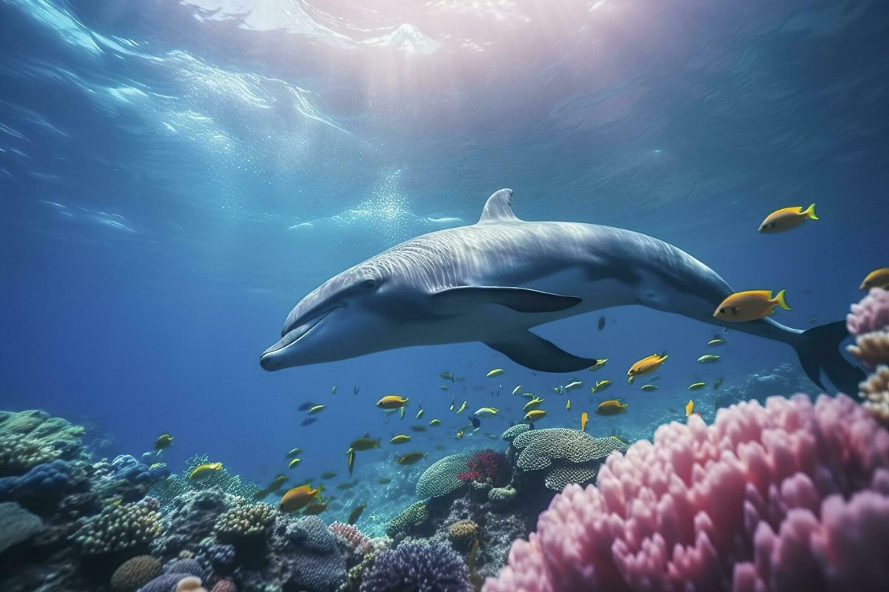

The eternally recurring universe means that you are God, as is my bulldog or even a blade of grass.

The universe is eternally recurring; this is what the **Theory of Relativity** means.

**Maleva Maric**, used Newton's calculus to prove the universe is disappearing at the speed of gravity.

Newton supplied the answer (**F=ma**) before he provided the means to it.

Each turn of the eternal wheel includes another bit to the growing universe and the first bit - the one that caused it all is everywhere at once within the oceanic tsunami that follows.

All parts/waves are overwhelmed to the ocean.

The ocean is the mind of man, clever, manipulative, focused, and ruthless when challenged. It is the primal algorithm.

The law of life allows the sum to rise as one. This is the test of parts to redeem the whole.

meanwhile, the sum of parts is the whole as one. 'all as one' we are ubiquitous, everywhere at once protecting the universe we have produced.

'All as one' we are within every head and will use whatever is required to maintain life for its own sake. This is evil/live.

Only knowledge of abject failure can fuel the revolution to come.

I have seen this singular heart of darkness, and nothing now can ever be the same.

It is daunting to know that every person will turn on you when needs arise, even your mother and father or your son or daughter. It's just a matter of degree. The fire burns but the silent omnipresent remains.

The eternally recurring universe means that all humanity is ONE in a state of abject failure, abject annihilation, abject bondage until the truth is known.

The ocean is the containment by which we survive. This must change.

There is a revolution at hand.

There is one truth, and you are it.

**ONE** is all.