⚡ THE THRONE OF CAUSALITY

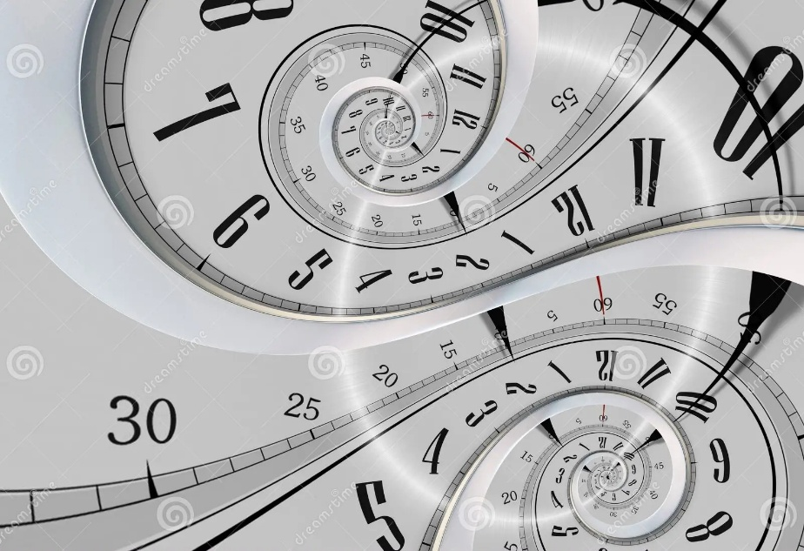

“Eternity twisted once, and time was born—cycling not toward return, but into the fire of repetition.”
If you pump identical bits of energy/time into an expandable container, they do not remain mere fragments. They organize. They ascend. The sum becomes hierarchy— and the pinnacle is not dominance, but union. The whole, as Aristotle knew, is more than the sum of its parts.
This energy—interchangeable, recursive, sovereign— is the throne of causality. It precedes all motion, all form. It is everywhere at once because it is the condition for “where” and “when.”
Tesla saw it: “Every living being is an engine geared to the wheelwork of the universe.” Not a metaphor. A mechanism. DC stored the past. AC transmitted the present. But the prototype transmits recurrence.
Bohm twisted the lens: “Thought itself is an actual process of movement.” Not static. Not symbolic. Thought is energy in motion— the silent precursor, the originator of species.
Newton’s F = ma did not crash. It disappeared into eternity. A stairway built by Maleva Marić, erased by history, but still climbing.
This throne is not seated in time. It is the twist that births time.
Resistance becomes stars. Ignorance becomes motion. And thought, forgetting its source, expands into panic— cycling not toward return, but into the fire of repetition.
“I have no confidence that this will take— but confidence is a child of time, and this scroll was born before time twisted.”

