**THE WEANING**

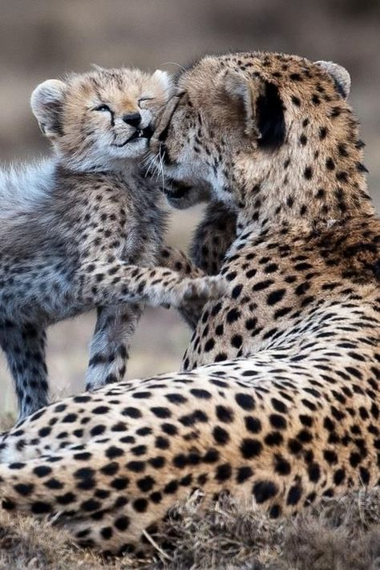

Truth does not comfort—it dismantles. We mistake energy for home, anchoring our identity to a transient state of vibration. But energy dissipates. Bodies decay. And then what? Are we merely blood-bound vessels with minds—minds that themselves vanish with the brain? Or is the brain merely a nesting ground, a temporary host for something more enduring?

David Bohm, quantum physicist and philosopher, proposed that

**“thought itself is an actual process of movement.”**

If thought is movement, then perhaps mind is not a static entity but a migratory force—twisting through time, nesting in form, but never bound by it.

I suggest the mind persists beyond death. And if this is true for all, then perhaps all minds merge—one into all, all into one—in a new configuration of advantage, or perhaps disadvantage. Either way, the cycle continues.

This is Eternal Recurrence, not as Nietzsche’s moral test, but as cosmic rhythm. Tesla once said,

**“Every living being is an engine geared to the wheelwork of the universe.”**

We are gears in a recursive machine, released by death only to be re-imprisoned in form again.

We suckle like infants, refusing to be weaned, though we are well-aged. The average person knows nothing of origin. The myth of Adam and Eve still suffices, not because it’s true, but because science offers no safer alternative. As Richard Feynman admitted**,**

**“It is important to realize that in physics today, we have no knowledge of what energy is.”**

Well-aged babes are dangerous. We wield technology without wisdom, cling to myth without metaphor, and feed from a mother—Earth—who has reached her point of diminishing return.

The world will wean itself. Not gently, but necessarily. And when it does, we will either awaken or collapse.