**TRUTH IS ANATHEMA**

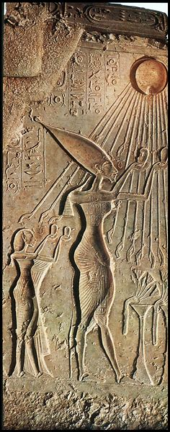

The average person has little curiosity about the facts of life. Rarely will one find conversation on the mechanics of energy— though energy animates everyone and everything.

I publish well-established truths—from Isaac Newton’s laws to the Tao Te Ching’s flow— only to discover that people are conditioned against acceptance. This resistance is not accidental. It is the natural consequence of energy itself—expressed through the Collective experience.

Every individual is a thoughtform. The sum of thinking is thought. And though thought is the sum of our thinking, it nonetheless produces an **emergent principal**—that is everywhere at once.

Observe the sun disc closely and you will discover this emergent principal),

**“The whole is more than the sum of its parts.”** — Aristotle

No matter how brilliant an individual may shine, all is washed back into the collective one.

The status quo is preserved. And this is why truth becomes anathema.

Eternal Recurrence is the truth of energy— introduced not by Nietzsche, but by Pharaoh Akhenaton in 1500 BC. He raised the Aten—the sun disc—as the singular source, its rays ending in hands that offer life. A symbol of recurrence, not abstraction. A movement, not a myth.

**“The sun rises, the sun sets, and in its movement we are reminded: all things return.”** — Akhenaton-inspired paraphrase

The figure within the sun disc is the resistance of all as one. It is cause and effect. It is the loop that holds brilliance in orbit. It is the twist that refuses to break.