VIRUS

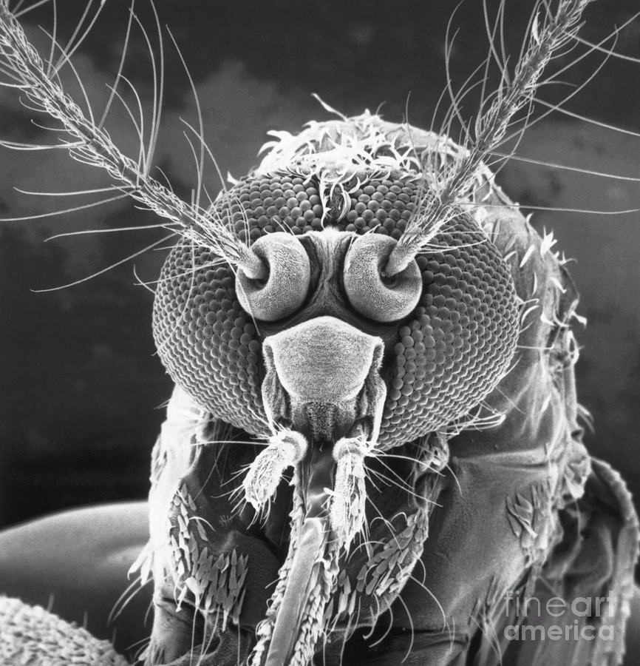

Until there is a mass shift in consciousness, there will be no meaningful movement toward our origin.
The dice is loaded. No person, from the beginning of time, has known that every event ultimately serves the continuation of life for its own sake.
We begin twisted, and remain so, until we recognize that this is a virus—an energy that owns everyone from the shadows. It is the sum of who we think we are.
This is not metaphor. It is the primal algorithm. Until we see it as such, we will not understand that we are inseparable from it.
From the beginning of time, no one has defined this force. It attacks anyone who comes close to exposing it.
I am one who dares. I have suffered its retaliation for a long time.
Its attacks are proof of its presence. Power reveals itself through resistance.
Soon, it will have to kill me. I accept that.
In the meantime, I call out humanity for its complicity in this algorithm—this force that sits on every shoulder without challenge.
There can be no claim to positive action until we admit that life itself is a virus that we cannot begin to cure until we understand its origin and purpose.
Until then, there is no recovery—only temporary relief.
Under the microscope:
A virus is a microscopic agent of pure cunning—neither fully alive nor truly dead. It consists of a strand of genetic material (DNA or RNA) encased in a protein shell called a capsid. Some viruses also wear an outer envelope, stolen from the host cell’s membrane, like a disguise.
Here’s what makes a virus distinct:
🧬 No independent life: It cannot reproduce, grow, or carry out metabolism on its own.
🧠 Hijacker by design: It invades living cells and reprograms them to produce copies of itself.
🔁 Replication cycle: Once inside, it forces the host to churn out thousands of viral replicas—often killing the host cell in the process.
🌍 Universal reach: Viruses infect all forms of life—humans, animals, plants, fungi, even bacteria.
🧨 Evolutionary pressure: They’ve shaped the course of life on Earth, triggering pandemics, driving genetic change, and challenging our definitions of life itself.
In essence, a virus is a rogue fragment of code—efficient, relentless, and utterly dependent on the living to make its mark. It’s not just a biological entity; it’s a lesson in parasitic persistence.
.
.
.
PICTURE: Electron microscope.

