**WELCOME TO THE JUNGLE**

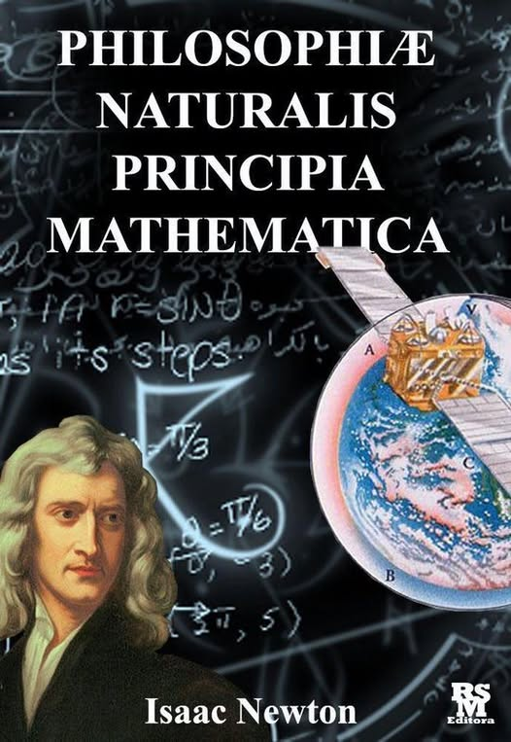

The most misunderstood equation is also the simplest. Isaac Newton’s **F = ma** is a movement disappearing out of time.

**“Force equals mass times acceleration”** — Newton’s Second Law, Philosophiæ Naturalis Principia Mathematica (1687).

What is remarkable, the movement repeats without cost until the resistance that caused it is reconciled. The repetition becomes the seeking universe growing itself to find itself within itself.

**“The universe is a twisting movement attempting to right itself.”** — Bohm, Thought as a System (1990).

The entire universe is going out of time with F = ma. Newton recognized the divine purpose of resistance and invented Calculus to guide us back to the prize.

Newton’s calculus was not just a tool—it was a metaphysical compass. His view of space as **“God’s sensorium”** reveals a deeper cosmology.

Two centuries later, **Mileva Marić** used Calculus to formulate The Theory of Relativity — the disappearing universe in a nutshell — the complexity of thinking reduced to its common denominator: F = ma.

Marić, a Serbian physicist and Einstein’s first wife, studied advanced mathematics and physics at ETH Zurich.

Her use of calculus as a stairway to heaven was side-tracked by **E = mc²**- crashed and burned at the speed of light.

Tesla called Einstein’s relativity **“a beggar clothed in purple whom ignorant people take for a king”** — New York Times, 1935.

Welcome to the jungle!