**🔓 THE SILENT CODE**

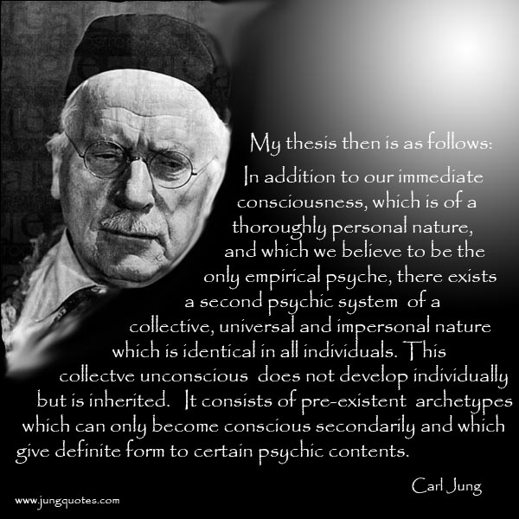

We began as One. Not one person, not one thing—just One. A unity so complete it had no edges, no name. Call it Love. Call it Eternity. Call it the beginning before beginnings.

**“Ultimately, all moments are really one, therefore now is an eternity.”** —David Bohm

Then came the twist. A ripple in the stillness. Energy turned inside out—like a Mobius strip folding on itself. This twist wasn’t a break. It was movement. And movement is thought. Thought is the first resistance.

**“As careful attention shows, thought itself is in an actual process of movement.”** —David Bohm

Gravity pulls everything back to One. But the twist repeats—again and again—until the resistance is understood. Until the distraction becomes recognition. Until the parts remember the whole.

**“The whole is more than the sum of its parts.”** —Aristotle

This is Eternal Recurrence. Not punishment. Not fate. But the rhythm of return. Each cycle is a chance to remember Love.

Energy is the language of this rhythm. Newton saw it in motion**: F = ma**. Planck measured its smallest pulse: **the quantum**. Tesla harnessed it—**alternating currents** echoing the cosmic twist.

**"Einstein’s relativity work is a magnificent mathematical garb which fascinates, dazzles and makes people blind to the underlying errors.”** —Nikola Tesla, New York Times, 1935

**“All matter originates and exists only by virtue of a force… We must assume behind this force the existence of a conscious and intelligent Mind.”** —Max Planck

The universe isn’t random. It’s a pattern. A dance of opposites. A generator of awakening.

The silent resistance is everywhere at once. In our distractions. In our longing. In our search for meaning. Every twist is a step toward home.

But the sum of who we think we are, is a singularity acting through its parts— everywhere at once, protecting our facades with as much power and violence as necessary. It is without compassion.

This is the will of the people enacted with impunity.

I am defenseless as it attacks my being, full knowing I have broken the code of silence. Now I will watch the awakening as clarity prevails.

It only takes **One.**