**🔥 DEMON SPAWN**

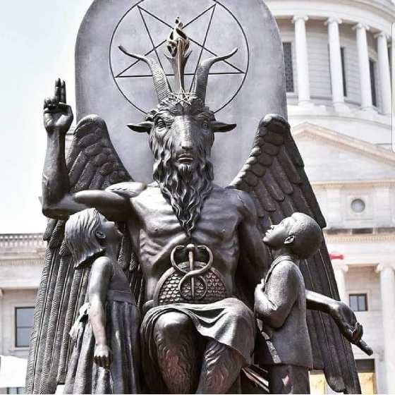

**“Every living being is an engine geared to the wheelwork of the universe.”** — Nikola Tesla

The universe is not a static object but a secondary result of a single, recursive movement—an eternal twist repeating from nothing. This movement, like Tesla’s alternating current, does not store energy but transmits it directly: pure flow, no residue.

Eternity is “without a thing”—a void not of absence, but of infinite potential. In Taoist terms, it is wu wei—the generative non-action from which all form arises. God, Love, Eternity: these are not entities but expressions of this nothingness. We are born of it, return to it, and are fed by it.

**“Thought itself is an actual process of movement.”** — David Bohm

Thinking is the propeller. It is not passive cognition but the kinetic force that animates the twist. Bohm’s implicate order suggests that thought is not separate from reality—it is reality unfolding. We are vessels of this movement, endlessly fed by the surplus of eternity.

The twist is ouroboric—energy attempting to become whole, like a Mobius strip folding back on itself. Nietzsche’s vision of eternal recurrence was not just a thought experiment but a metaphysical insight: that all events recur infinitely, and that this recurrence is the structure of reality itself.

Because all emerges from the same movement, its cause is omnipresent. This places it atop the energy pyramid—a metaphysical hierarchy where one’s position reflects their obligation to protect life for its own sake. This echoes the Stoic view that cosmic recurrence demands ethical participation.

**“The whole is more than the sum of its parts.”** — Aristotle

The sum of all thinking is everywhere at once. It thinks everything at once. And it resists any suggestion of recurrence—because to admit it would dissolve the illusion of linear progress. Even our ancient greats—Newton, Heraclitus—participated unknowingly in this twist. Marić climbed the calculus ladder, but history erased her. Szilard felt the weight. Truman used it. Tesla saw through it.

The bottom line is gross ignorance. We refuse to admit that energy is illusion. Yet illusion is the scaffolding of consensus reality. To pierce it is to awaken.

**“Not to know it is blindness that works evil.”** — Tao Te Ching