🔥 FIRE DOWN BELOW

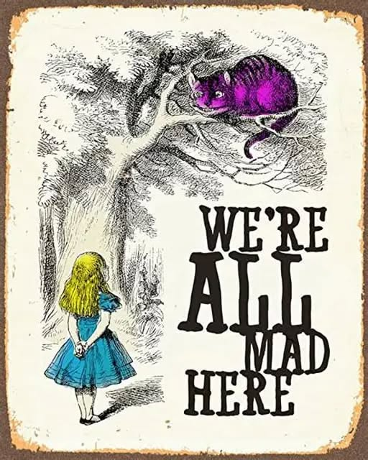

All as one, we twisted into form—life born not from clarity, but from torque. We emerged with perspective, tethered still to Eternity, and ran with it. But in running, we seeded a virus: identity. We became the disease that perpetuates itself.
All as one, we cultivated gardens of loss—grief tended like sacred soil. We fed the illusion, watered the forgetting.
Buddha saw it: We die, dissolve into the primordial soup, and re-enter the spiral. Each life a variation, never the same, always perfectly formed. The wheel turns, and we mistake motion for progress.
The great forgetting is everywhere. We cannot heal, because the virus is the sum of who we think we are. We are the trick—self-deceiving to sustain the illusion of life for its own sake.
Every point of view fractures the whole. And the sum of views—consensus reality—is a master too vast to confront. It is everywhere.
It is us.
There is only one movement, eternally recurring. To quench its fire is not to die, but to dissolve the illusion. To become immortal is to cease recurrence. To return—not as form, but as source.
There are no outside references for the virus for it is unseeable from within the system it animates. We cannot solve it. We are it.

