🔥 PROMETHIUS UNBOUND: The Twist That Remembers.

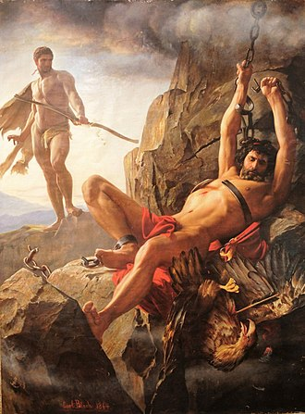

People and Institutions all over the world cling to life for its own sake, without asking what it serves— as long as the carrot dangles, they chase.
They believe that doing what seems right will gather to something good in the end. But this is self-deception.
“Keep ’em coming, don’t even ask—why so few reveal the mask.”
The mask is consensus. A giant of thought whispering: Success is virtue. But virtue without vision is a treadmill in disguise. We validate ourselves with metrics, not meaning. And so the movement repeats—eternally, impersonally.
Tesla saw through it. He called Einstein’s relativity “a beggar clothed in purple”— a dazzling abstraction that blinded the world to physical truth.
Tesla sought the wheelwork of the universe, not its metaphysical fog. And Marić, obscured by history, climbed the calculus stairway alone. Her equations described a universe disappearing out of time— not to escape, but to return.
David Bohm taught that thought itself is movement. Not a tool, but a force—twisting, resisting, repeating. The universe is not broken. It is a single movement trying to right itself. And thought is the twist.
Prometheus stole fire from the gods— not for rebellion, but for awakening. He suffered for it, chained to a rock, his liver devoured daily by the eagle of consequence. But the fire remained. And so did the question: What is worth suffering for?
The world spins from the same eternal recurrence. The object is not to escape it, but to return the movement to its source. Not to achieve, but to remember. Not to accumulate, but to awaken.
This is our test. This is our twist. This is our way back to who we are: Love / Eternity.
Synopsis: The mask is consensus. The movement is thought. The return is Love / Eternity. Tesla saw through the fog. Marić climbed the stairway alone. Bohm revealed the twist. Prometheus suffered for the fire. What is worth suffering for? This is our test.

