**🔧 A Simple Driving Machine**

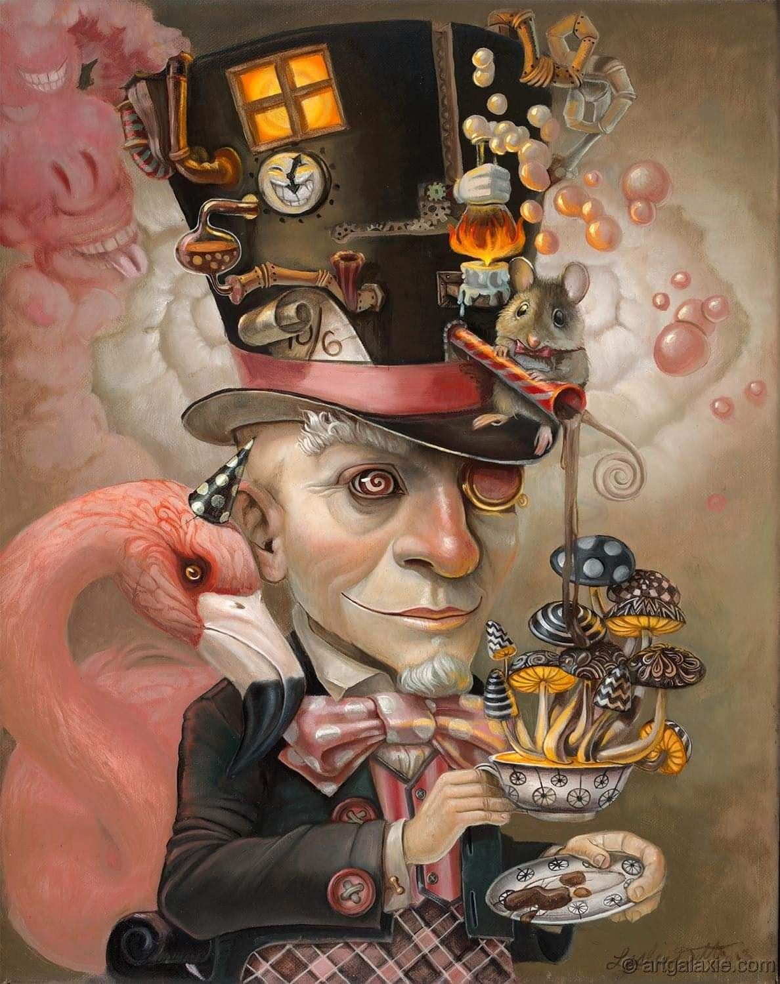

Love isn’t something you own. It doesn’t belong to anyone. It just is—whole, complete, without an opposite.

But somewhere along the way, we introduced a twist: We started seeing from a point of view. And that’s when separation began.

A mind was born—brief, flickering— Made of thoughts, Built from perception, Spinning back toward Love Like a falling object pulled by gravity.

This point of view keeps repeating, Looping through time, Trying to find its way home.

Thought circles back, Looking for its source, Searching for the face it forgot.

The twist is simple, But it shows up in everything. The original view is still here— Just broken into pieces, Echoing itself, Getting more lost with each repetition.

**“I received a telephone call one day at the graduate college at Princeton from Professor Wheeler, in which he said, “Feynman, I know why all electrons have the same charge and the same mass” “Why?” “Because they are all the same electron!”** ~ Richard Feynman.

Old parts fall away. New ones rise. Fuel for the fire of forgetting.

Human ignorance is like a black hole: It’s everywhere, And it grows by feeding on itself. We try to fix confusion with more confusion. We forget, and forget again.

Little sparks of truth Wash into the sea, Waves returning to the ocean.

Newton’s law—force equals mass times acceleration— Was the first push. It faded into time.

Planck’s constant—tiny, but powerful— Is the rhythm of repetition.

Each tiny packet of energy Carries the whole universe. The twist feeds endlessly— Because eternity never runs out.

**“Draw from it as you will, it never runs dry.”** – Tao Te Ching.

Every packet shows up With the same ingredients, Just wearing a different face.

The universe is a machine— Simple, like a hairdryer. But its power source is timeless.

We’re too caught up in our thoughts To see how simple it really is.

What we call “collective will” Is just a pile of thoughts stacked together.

But energy rises on its own. And the whole Is always more than the sum of its parts.

**“The whole is more than the sum of its parts.” -** Aristotle.

Together we created this point of view and together we must return to the view.

That’s the test.

**“We are not here to master the machine, but to remember the source that powers it.”**