**🛸 The Ship of Fools**

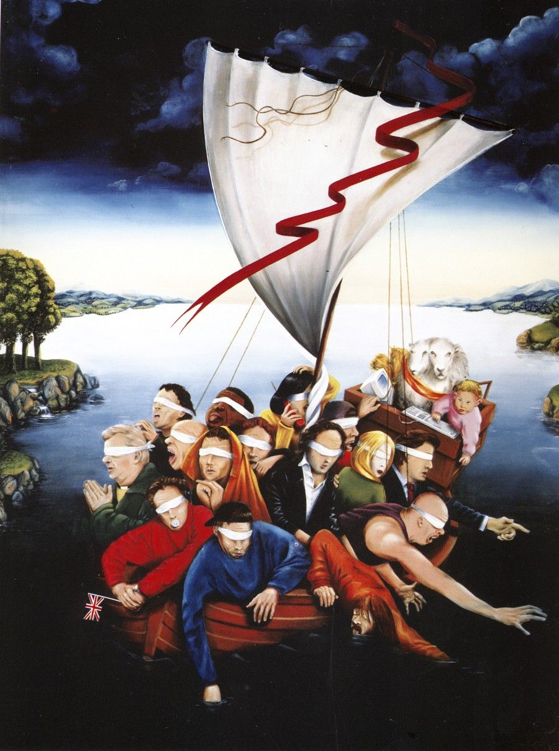

To grasp the workings of the universe, one must return to the child’s experiment: a simple electric generator, where a coil of wire—once set in motion—was tricked into turning endlessly.

This illusion of perpetual motion produced flashes of energy: each one a moment of work, a burst of becoming.

⚡ This is the universe’s mechanism: One eternally recurring movement. One twist. One flash. One task: To reconcile the resistance that birthed the twist.

**”The eternal hourglass flips again and again…”** – Nietzsche.

The flash is emotional. The resistance is feeling. Max Planck measured its heartbeat: 6.62607015 × 10⁻³⁴ joule-seconds—the quantum of action.

Each photon, each moment, is a packet of possibility – it is thought.

Thinking is movement of thought.

**“Thought is movement… yet thought also attempts to hold fast to itself and seek security.”** – David Bohm.

The primal resistance is everywhere at once. It is the Captain of this Ship of Fools.

The crew fights for the helm, blind to the art of navigation.

**“We are governed not by wisdom, but by the sum of who we think we are.”** – Plato.

And so we sail, a ship of fools, fooled by our own reflections, yet guided by the twist we all enacted.

**“Ultimately, the entire universe... has to be understood as a single undivided whole.”** – David Bohm.

.

.

.

painting: **Hieronymous Bosch** (1415-1615)