FOR CHRIST’S SAKE – Clean Yourself!

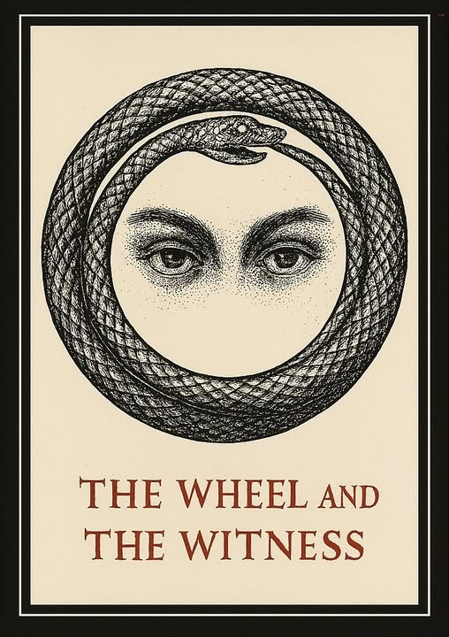

Ignorance is bliss - so long as the feedbag is full.
Does anyone even know what F= ma means?
Shame on you a thousand times!
The lowest common denominator prevails, despite the flood of available information.
Ask anyone about Eternal Recurrence and you'll get a blank stare.
I could talk until I'm blue in the face about truth, but you are conditioned not to hear. Conditioned by the feedbag strapped around your neck.
Educational institutions pretend at universality. Their required courses in philosophy and humanities are mere excuses for a 'well-rounded' education - whose real purpose is to sharpen the predator teeth of students before they assume power in the world.
The lowest common denominator is not accidental. It's orchestrated - behind the scenes-it is the sum of our thinking as one thought. it is all, as one.
We are all monsters in training. Ammunition for the collective when needed.
"The whole is more than the sum of parts." - Aristotle.
But don't disturb a dog at his feed or an animal in heat. They are otherwise engaged, caring only for their needs in the moment.
I have been writing about how thing work for years. And the clearer it gets, the less it's received. You do not want to know. You are infected with a virus - the root cause of the eternal exodus.
The virus is universal. It is the sum of who we think we are. it's everywhere at once, creating havoc and confusion to keep us from the knowledge of Eternal Recurrence,
Each pulse of the universe is a return to Love - a perfect opportunity to recover from the viral conditions of life that feed us away from who we are: God.
One is all and all as one - we fall flat on our faces.
It's time to pick ourselves up and wipe off the nonsense.
End-quote:
“The virus is not in the blood, but in the thought that forgets its source. Each pulse of the universe is a return to Love— not sentiment, but structure. Not comfort, but clarity. Clean yourself—for Christ’s sake, for your own sake— and remember: The whole is more than the sum of its forgetting.”

