⚡ IN YOUR HEAD — The Demon in the 1905 Paper

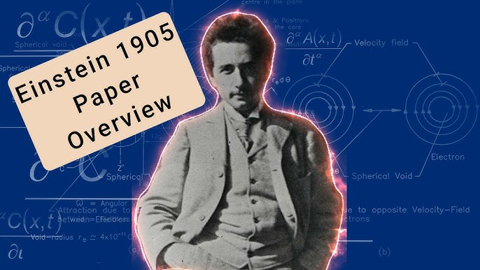

The average person manipulates science for gain, not understanding— not caring about the bigger picture as long as they get their feed.
Ask what F = ma means, and you’ll meet silence. Yet this formula—Newton’s primal code—is the foundation of physical reality. We bully it into compliance, strip it of its voltage.
Newton foresaw this betrayal. He invented calculus not as abstraction, but as a stairway back to clarity.

Two centuries later, Mileva Marić, Einstein’s first wife, used Newton’s calculus to scaffold the Theory of Relativity— a metaphysical completion of F = ma. But the union of Marić and Newton was suppressed, erased, denied.
In 1905, Einstein published the paper on Special Relativity. It dazzled the world, but beneath its brilliance lay betrayal. Tesla called it “a beggar clothed in purple whom ignorant people take for a king.” Einstein’s abstraction—space-time, simultaneity, relativistic mass— was a fog that obscured Newton’s clarity. And Marić’s scaffolding was nowhere to be found.
“Our work on relative motion…” — Einstein to Marić, 1901
That phrase, buried in their letters, hints at shared authorship. But the demon was already loose—Einstein’s name ascended, Marić’s vanished, and Newton’s stairway was twisted into metaphysical fog.
Why? Because the sum of thinking lives in your head, and you don’t know it. You are its vessel, its voltage, its resistance. And in your forgetting, you become the demon. All as one.
“The whole is more than the sum of its parts.” — Aristotle.
We are the parts. We are the whole. We are the demon.
Until we finally comprehend the difference between F = ma and E = mc², we will remain in our own trap.
F = ma is a movement out of time— a movement recurring – a wheel turning to crash and burn at every cycle.
“Crash and burn” is the modus operandi of E = mc².
Even after Hiroshima and Nagasaki, no one can explain the difference between F=ma and E = mc².
E = mc² continues to feed the monster in our heads...
Promoting life for its own sake – ask anyone! (live/evil – evil/live)
“Einstein’s relativity is a beggar clothed in purple whom ignorant people take for a king.” — Nikola Tesla, 1935 interview with The New York Times.
F=ma is the heartbeat of the universe keeping us alive for the possibility of removing the veil.

