THE EYE OF C

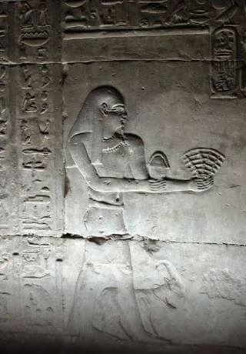

“Each return is the first dawn.” – Lord Of the Rings.
It’s as simple as ABC.
The difference between A and B is caused by the resistance that caused it.
In a nutshell this is the core of humanity—from an acorn a mighty oak grows.
The mighty oak forgets its beginning and therein lies the challenge.
Isaac Newton described the movement between A and B as ending in eternity/nothing—Love as dissolution.
Max Planck established the energy of the movement: Planck’s Constant.
Nikola Tesla realized the movement as eternally recurring and used the knowledge to invent Alternating Current.
Summary:
A to B ends in eternity but continues to re‑appear. We are the aggregate of the alternating movement, unaware of C.
C is everywhere at once. It is a constant beginning.
Each repeat is brand new.
The aggregate is a build‑up of resistance under the eye of C.
“The mighty oak forgets its beginning and therein lies the challenge.”
C watches as we stumble about giving perfect responses to all actions.
"Perfect. perfect, always perfect!"
C was the first to know and we are the last to learn.
“Energy is eternal delight.” – William Blake.

