⚡ THE FORCE OF GRAVITY — Whittled down.

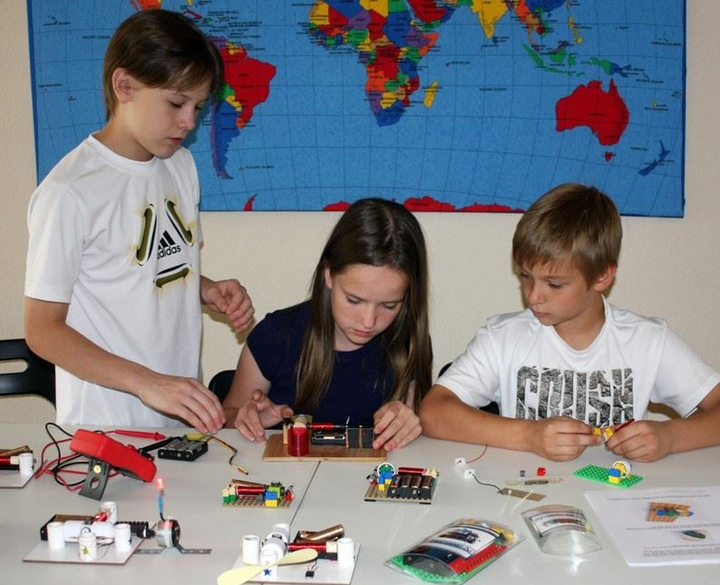

Isaac Newton, by whatever means, gave us the all-inclusive statement: F = ma
Force (F) is mass (m) x its acceleration (a). But this is not mechanics. It is a ritual of disappearance.
Acceleration (a) does not crash or collide. It terminates—quietly, infinitely. It disappears out of time. It is the vanishing arrow, not the arc of motion.
Mass (m) is not a thing. It is the structure of movement, the shape of resistance as it dissolves into eternity. Not substance—but scaffolding for release.
Force (F) is the pressure of this structured vanishing. It is the voltage of elimination. It is GRAVITY—not as pull, but as ritual disappearance.
Gravity is the force of a 'particle' built to vanish. F = ma is not a law—it is an eternally recurring movement producing output.
The entire universe is analogous to a simple generator.
“Every living being is an engine geared to the wheelwork of the universe.” — Nikola Tesla
.
.
.
.
School Project: building a generator.

