THE MECHANICS OF TIME
Gobbled up by our own malfeasance.

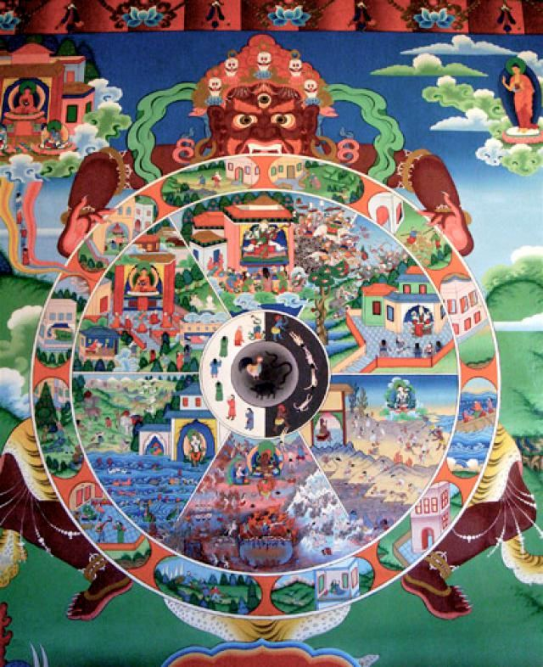

The world is hell on earth, everyone scrambling to appear authentic—none are.
Until the mechanics of time are known, all is guesswork.
Time began when ONE IS ALL turned on itself and became ‘all as one’ for a moment of time.
This tiny bit of time is well documented:
Isaac Newton described it as a movement out of time and presented it as F = ma—a soft landing, eternity. Newton knew we would not believe this, so he invented Calculus to give us a leg up. We are still falling off the horse.
Max Planck discovered the movement’s energy (6.62607004 × 10⁻³⁴ m²·kg·s). This is Planck’s constant.
Nikola Tesla knew that time was the accumulation of the same bit of energy gathering into the universal container—like a balloon swelling with volume. Tesla used the recurring movement to invent AC. The universe is the generator; AC is its echo.
The Theory of Relativity brought it all together under the brilliant applications of Mileva Marić.
Marić was Einstein’s wife, but women were not recognized as credible, so Einstein alone signed the famous 1905 paper.
Marić was cast aside as Einstein bungled her work at the speed of light—Hiroshima, Nagasaki.
The universe is the same eternally recurring movement, producing output just as does any generator.
In spite of Marić putting wheels under Newton’s thesis, it amounted to nought—because no one is aware that the sum of secondary parts is a collective force that protects the truth from being known.
“The whole is more than the sum of its parts.” — Aristotle
No one knows that we surreptitiously employ this dark angel to protect who we think we are.
This is a dirty trick we play on ourselves, to pain us into recognition of the mechanics of time.
“The wheel turns without end; recurrence is its rhythm, eternity the soft landing.”

