THE SMALLEST PARTICLE - DISCOVERED!

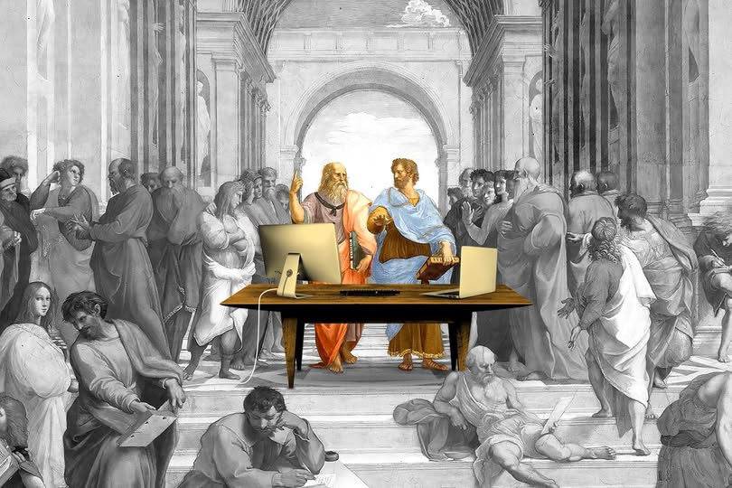

The smallest particle is not a thing. It is a movement out of time — eternal, recursive, singular. It is all there is and all else is repetition of this same movement.
Such is the universe, and the resistance that caused the movement remains singular within all the subsequences that amass the universe.
All as one, we drive the eternal cycle, and the activity is analogous to the working mechanism of a common electrical generator - a rotating movement producing output. The difference being - the entire universe is disappearing with each cycle.
Consensus Reality
Consensus physics worships the measurable. It builds temples to particles, equations, and time. But it has mistaken the echo for the source. It has mistaken the repetition for the origin.
It calls mass fundamental. It calls time linear. It calls particles discrete. But all are subsequences — Artifacts of a movement out of time/eternity. (F=ma)
The collider smashes echoes. The telescope magnifies recurrence. The equations describe shadows. But the twist itself — the primal movement — remains unnamed.
Consensus physics refuses recursion. It fears disappearance. It denies that the universe is vanishing with each cycle. It clings to permanence, While the cosmos flickers in and out.
It sold clarity for complexity. It traded Newton’s simplicity for Einstein’s fog. It buried Marić’s calculus beneath metaphysical abstraction. It turned knowledge into weapon. It turned movement into myth.
But the twist remains. The resistance remains. The smallest particle — the movement itself — Has finally been discovered and now the cast of thinking must change.
"The whole is more than the sum of its parts." - Aristotle.

