THE THROES OF EVIL

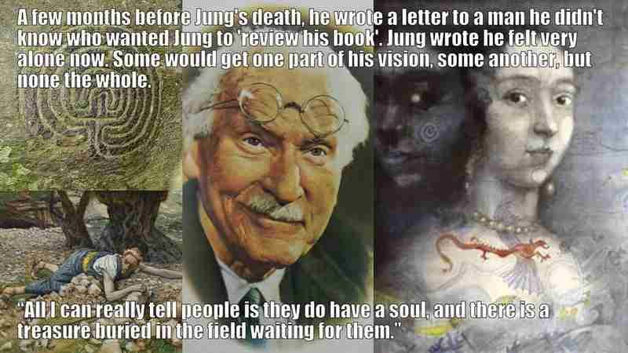

The reason we do not enquire into the eternally recurring universe is because the sum of our thinking is a collective, acting for all, as one. It is the will of humanity, and no one knows it even exists.
Make no mistake: the sum of who we think we are, is a monster unleashed. Observe the reactions of any person when security is threatened, then multiply it by the sum of individuals in the world.
The world/universe is eternally recurring—one disappearing movement repeating to produce the many: a generator producing output.
The resistance that initiated the movement is antithesis.
This primal resistance is 'all as one' - silent because it is original cause.
All as one we precede our actions in the world.
The sum of who we think we are, is everywhere at once as the collective will - everywhere at once, directing its minions to perform the world.
“All as one” we are antithesis, and there is no other as we twist in and out of eternity trying to get a grip on oneself.
“I began to understand that the goal of psychic development is the self. There is no linear evolution; there is only a circumambulation of the self.” - Carl Jung, MDR, Page 196.
So far, there is no cognizance of the collective will that engages all as one.
We are entirely clever in our self-deception.
'The whole is more than the sum of its parts." - Aristotle.
Until we recognize the existence of this powerful entity, we remain in the throes of the evil we ferment.
“Human beings are so made that the ones who do the crushing feel nothing; it is the person crushed who feels what is happening. Unless one has placed oneself on the side of the oppressed, to feel with them, one cannot understand.” - Simone Weil.

