THE ZEROTH LAW

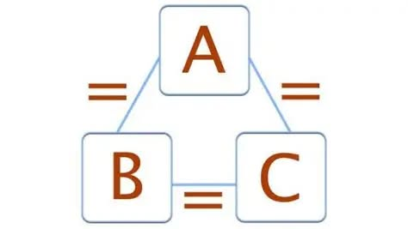

The key to understanding everything is through the all-inclusive equation: F = ma.
Newton’s second law is absolute, describing the universe as a movement going out of time to become nothing.
'Nothing' means 'without reference'.
This is absolute power - the power of equilibrium.
Achieved but for an instant; an instant that repeats until time has solved its cause - the cause of the movement.
For an eternal moment, the trinity is equilibrated out of time.
“The Zeroth Law of Thermodynamics defines thermal equilibrium and forms the basis of temperature: if two systems are each in equilibrium with a third, they are in equilibrium with each other.” – Wikipedia.
The Zeroth Law encompasses the first energy: positive, negative, and resistance.
Newton’s F = ma does not have a 'crash-point' on the way and lands softly in eternity at every turn.
The law of conservation of mass, first articulated by Antoine Lavoisier in the 18th century, demands that matter is neither created nor destroyed. Thus, F = ma repeats endlessly until the silent, hidden resistance of the Zeroth Law is reconciled in time.
The eternally recurring universe builds to learn, but the silent principal is everywhere at once as the sum of who we think we are.
“According to a theory proposed by theoretical physicist John Wheeler, who outlined his thoughts in a conversation with fellow physicist Richard Feynman, there is only one electron—it just looks like there are a lot more because it is moving forward and backward in time.”
The silent principal is the body of man, with the mind to live according to its own will.
The will of man is the sum of its own parts - the sum of who we think we are sits at the left hand of God, vested in its agenda to become God in energy.
Ask anyone if they live to die. Then consider the sum of human minds as the collective will. You will arrive at a demon you do not wish to know.
This is why, despite the works of Mileva Marić—a Serbian physicist who studied at Zürich Polytechnic and collaborated with Einstein—and the visionary Nikola Tesla, who saw energy as a universal force connecting all existence, we continue to abhor Newton’s F = ma.
F = ma represents one movement disappearing out of time, ad infinitum, producing the universe as a secondary issue— for the purpose of finding, and reconciling, the silent resistance within the Zero Law.
“F = ma is the movement without crash, the universe turning softly into eternity; the Zeroth Law is its hidden resistance, reminding us that energy is never lost, only transformed—each recurrence a silent equilibrium, a wheel without waste.”
.
.
.
.
A is silent between B and C.

