WILL O' THE WISP
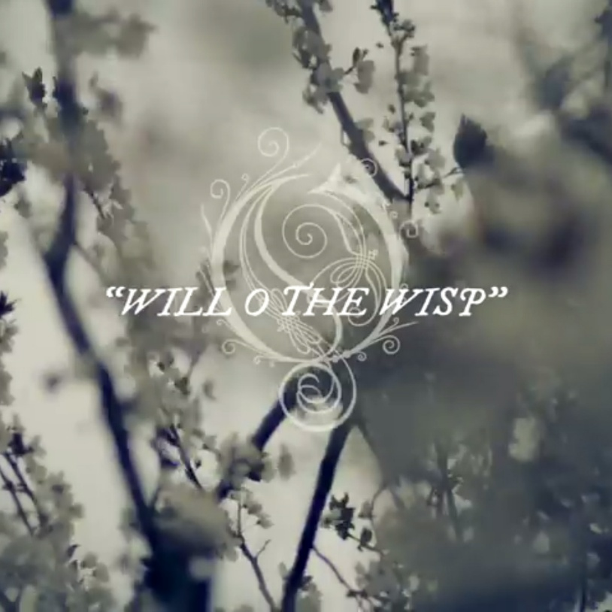
The closer we come, the more it jumps around.
Isaac Newton described the smallest particle as a movement out of time—F = ma. This was (and still is) so “off the wall” that he invented Calculus to help us find it.
Nikola Tesla discovered the particle as re-occurring and demonstrated it at the 1893 World’s Fair. Alternating current fueled the Industrial Revolution.
Soon after, Max Planck measured the energy of the disappearing particle. That measure is now known as Planck’s constant.
Then, a brilliant woman physicist named Mileva Marić used Newton’s calculus to build the “stairway to heaven” we now call the Theory of Relativity.
These points are foundational—yet remain distorted within the teaching institutions of the world.
*
WILLOW
Want to keep you in my sight
Close and clear, do not fear
I only want to be more clear
About the reason you’re here.
Every time I search for you
I feel you see me through and through
Looking at my fear bound mind
As if I am a curious find.
Maybe Willow you think of me
As flotsam in the open sea
Quite removed from all that's free
Afraid to release to one with thee.
But Willow, if for a moment you would sit still
We could be the best of friends
I would not fear your wisping whims
If I could but see your wings.
We humans must control you see
Otherwise, we can't be free
So, Willow, please don't flee!
Need to have you at my knee.

