🔥 THE TEST OF IDENTITY

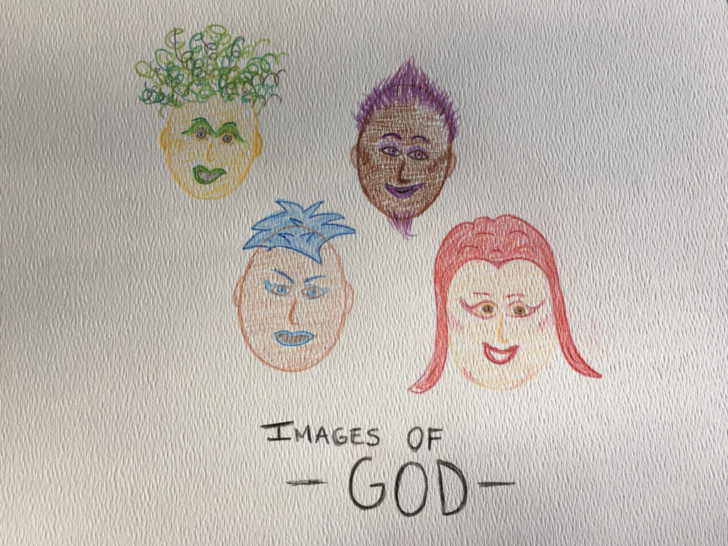

“Treat everyone that you meet as if they are God in drag.” – Alan Watts.

“As careful attention shows, thought itself is an actual process of movement.” —David Bohm

“Until you make the unconscious conscious, it will direct your life and you will call it fate.” —Carl Jung

“Not to know it is blindness that works evil.” —Tao Te Ching.
Thought is original resistance. It is 'all as one' saying “no” to what is.
We are love without condition—
And so we cannot abide
Until we learn why we choose
To be reduced to points of view.
The learning is fail-safe.
Never are we set adrift.
We twist, and the untwisting continues
Until our thinking finds thought in the dark
And brings it home.
All is emotional.
All is movement in a furor to become.
But the things we gain invariably own us.
Suddenly, we go from who we are
To being identified by the labels we create—
Hard-fought, well won, proudly displayed.
The search for divinity gets plowed under.
Distractions ferment to a singularity:
The sum of our thinking
As one being over-all.
We have created a demon
To protect our identities.
And we look the other way
When others fight to preserve our view.
We are owned and penned.
None can refuse when the demon calls.
Be it known:
There is no outside force.
There is no demon!
Only the sum of who we think we are
Exercising collective will with impunity—
Sooner or later, you too will be called.
This is the test to reveal.
And no matter how you are identified,
You must go back to the beginning
And understand:
The entire universe is eternally re-occurring
Until the primal resistance of “all as one”
Is known to be everywhere at once—
Each turn of the wheel
Is the beginning of time—
A return to love without condition.
Love is embedded,
But identity supersedes - for now!
“Every living being is an engine geared to the wheelwork of the universe.” —Nikola Tesla.
“F=ma“—Isaac Newton.
“The whole is more than the sum of its parts.” —Aristotle
This all will make sense If you can grasp the meaning
Of Newton’s all-inclusive statement: F = ma

The wheel turns.
The twist repeats.
And the All waits
For you to remember
What you never truly forgot.

One is All, now and forever shall be.
.
.
.
.
“Treat everyone that you meet as if they are God in drag.” – Alan Watts.

