FOOLS ABIDE

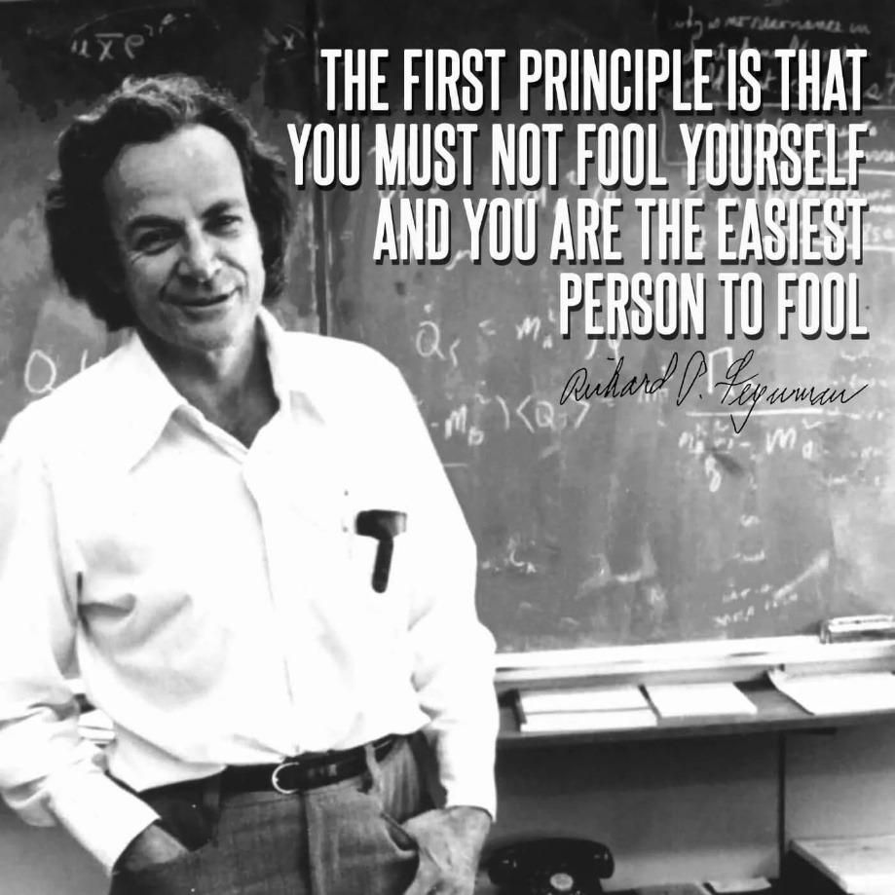

One eternal wheel pumping out the work to be done- just as a hairdryer or any generator, except the output here is the universe.
The work of return has been made easy, for we know the energy of the wheel as 6.62607015 × 10⁻³⁴ J·s.
This is Planck’s constant - the quantum of action.
We go out to gather back.
Every turn of the wheel is a free dollop of energy added to the collective whole, forming an energy hierarchy.
"The whole is more than the sum of parts." - Aristotle.
The resistance that precedes the wheel's movement is everywhere at once, and though diminished by its own growing ignorance, it remains everywhere at once.
Thought and thinking are one and the same - one with a twist.
"Thought itself is an actual process of movement." - David Bohm.
We, who are the body of thought, are as a spleen to an eyeball - organs of a larger whole, yet clueless about the arrangement that proceeds to protect our points of view.
A divine test, no doubt.
It is no puzzle except to fools.
~
The ones that shine the brightest:
Newton - who gave us Principia and the clarity of F =ma.
Max Planck, who opened the quantum door.
Mileva Maric, who carried Newton’s calculus forward, concluding F=ma as the stairway to heaven, only for Einstein’s relativity to knock it back, a wave dissolving into the ocean of ignorance.
Nikola Tesla, who electrified the world with alternating current.
All have been washed back by the collective will, like waves returning to the ocean.
The collective thought is as clever as it is ignorant — everywhere at once to prove it.
Richard Feynman recalled a call from John Wheeler:
“I know why all electrons have the same charge and the same mass.” “Why?” “Because they are all the same electron!”
Well, whoop de doo!

