LOVE

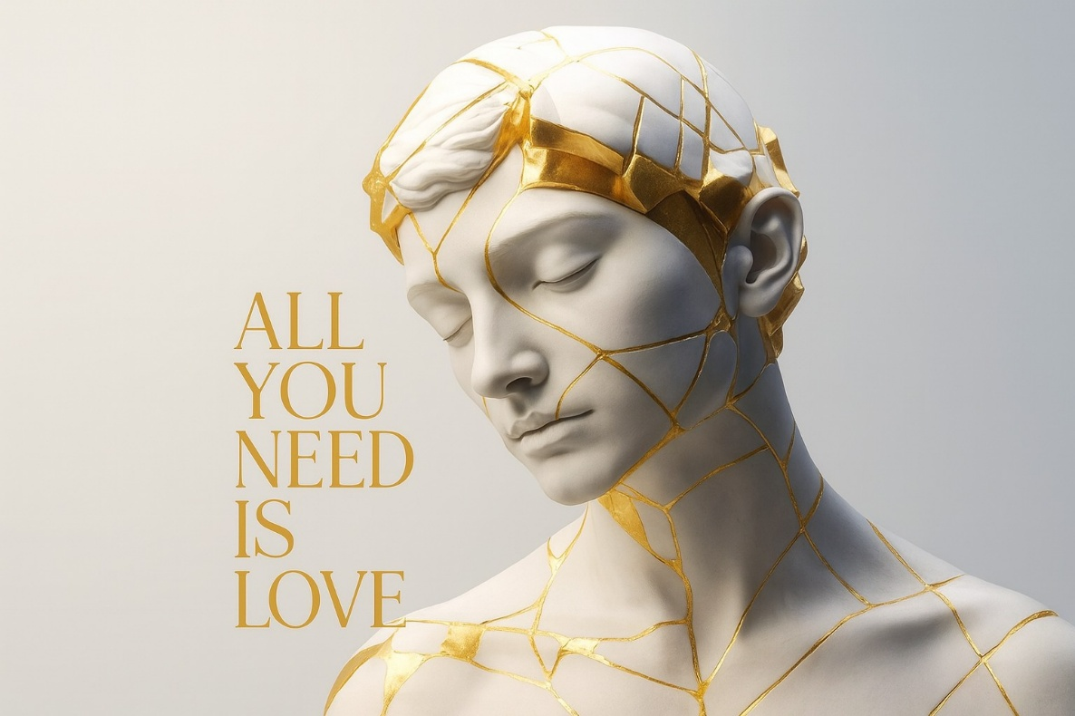

The center of being is a constant movement of precise energy and a changing face.
The energy is Planck's constant, limitless in availability, flashing in and out of eternity to meet the demand of thinking's changing face.
Thinking effloresces the universe, whose purpose is to discover the thought that initiated it - the one behind the works.
This precise energy is a movement whose repetition accumulates the universe, one face at a time, combining to become the collective face of all as one.
A turning wheel generating output.
"No man ever steps in the same river twice, for it is not the same river and he's not the same man." - Heraclitus.
Finding the thought that thinks is only a matter of isolating the quantum of energy and applying the knowledge we already know:
ENERGY IS MOVEMENT CAUSED BY RESISTANCE.
Thought is the resistance that caused the first movement, whose repetition produces the universe for the purpose of reconciling the resistance to its eternal source - the source of Love.
The sum of who we think we are is the thinking of thought chasing itself.
Meanwhile, the entire universe is saturated with Love.
We only have to see its movement and hop on board.
This is a practical choice that requires common sense.
~
REFERENCES:
Max Planck — the quantization of energy; the smallest indivisible movement.
Heraclitus — the universe as flux, tension, and the hidden harmony of opposites.
Gurdjieff — resistance as the necessary “shock” that enables movement and transformation.
David Bohm — the implicate order unfolding through continuous, repeating motion.
Whitehead — process philosophy: reality as events of becoming rather than static things.
Teilhard de Chardin — Love as the cosmic force drawing all things toward unity.
Spinoza — thought as an attribute of the one substance; Love as recognition of source.
Rumi — Love saturating the universe, waiting to be seen.

