THE COLLECTIVE BEAST

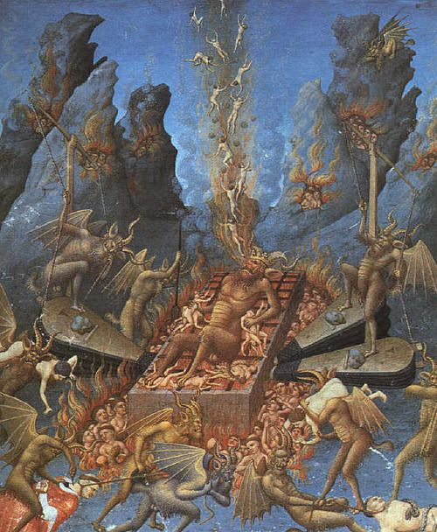

A ferocious non‑entity, generated by us, fed by us, denied by us.
We are the principal getting away with murder.
The universe emerged from one eternally recurring movement.
The movement is the wheel of life, and the universe is the result of its rotation.
A generator.
The resistance that caused the movement:
One became all as one for a moment in time —
to take a peek,
to gain a point of view.
A twisted thought.
And once the point of view appeared, thought began to think.
As time increased thought became lost in its own thinking -
yet it remained all as one,
no matter its current collective wallop of 8.3 billion bits of thought.
The collective will of humanity is a monster without compassion or empathy.
No one is to blame when all is one,
and we rise to the surface only to declare the truth too late.
"The whole is more than the sum of its parts." - Aristotle,
But the rising bits - Newton, Planck, Tesla, Tao Te Ching, and the rest -
are no match for the collective wallop.
The master of time is the collective will -
a ferocious non-entity everywhere at once,
maintaining life for its own sake,
at our behest.
We are this silent principal getting away with murder.
This is why the world is forever at war alongside the moguls of power -
one feeding the other,
taking no prisoners as the fire is fed.
The master of time is a hired gun ensuring we remain ignorant of eternal recurrence -
the knowledge that would shake the foundations of time.
Violence is the shadow of the ignorance that sustains it.
The collective will keep us ignorant by our own desire.
We, the parts, will not even admit that movement is illusion,
much less that we are its generated output,
lost in time.
The master of time is the sum of who we think we are -
8.3 billion vested interests.
All demons.
~
REFERENCES:
Heraclitus — the ever‑living fire, the unity of opposites, the river that repeats.
Parmenides — the unchanging One beneath the illusion of movement.
Plotinus — the One overflowing into multiplicity, then forgetting itself.
Nietzsche — eternal recurrence and the herd‑mind.
Spinoza — the single substance expressing itself in infinite modes.
Leibniz — monads mirroring the whole.
Bohm — the implicate order generating the explicate world.
Whitehead — process as the fundamental unit of reality.
.
.
.
.
Pic. by William Blake.

