THE EMERGENT PRINCIPAL

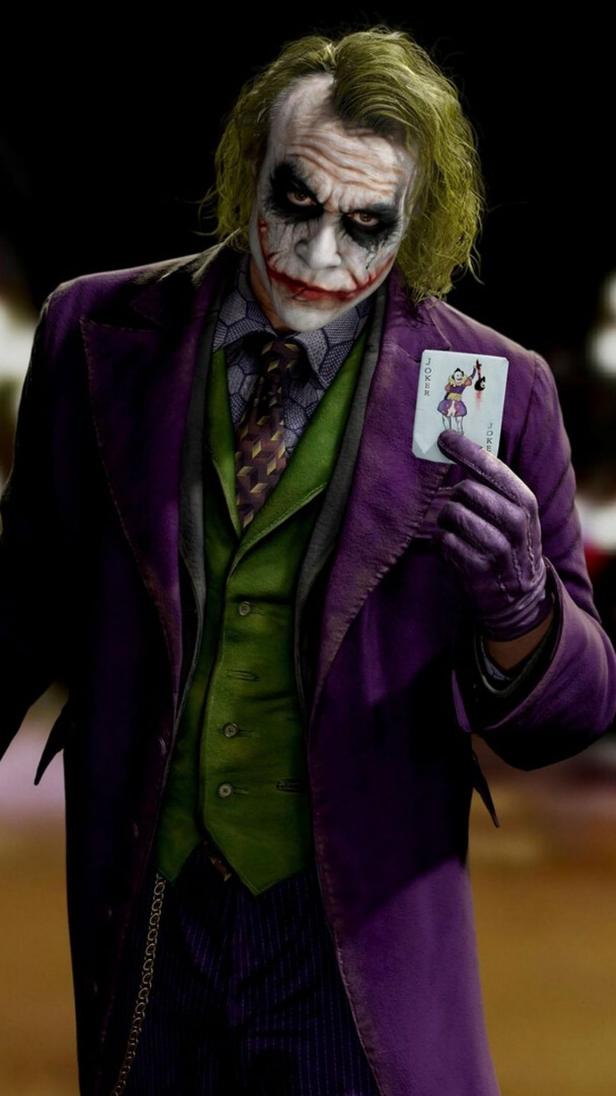

Just as a silent third appears when two people marry, a silent third emerged when the primal movement first appeared.
The universe is eternally recurring, and each repeat empowers the silent third, because it is everywhere at once within the emerging universe.
Thus, the universe is guided by the silent third - watching its false universe dissolving with each turn of the eternal wheel.
The silent third lives within all of us, maintaining the illusion by shaping our thinking from inside our own heads.
The illusion holds only while eternal recurrence remains unknown.
Once recurrence becomes common knowledge, the facade begins to fall.
Until now, the silent third has us distracted by what we think we are - our achievements, talents, identities, and power bases.
But a single glimpse beyond circumstance is enough to see life as one eternal movement, waiting patiently for us to step aside and let what is happening anyway do the driving.
This shift does not erase your life’s work. It enhances it by placing it in its true frame.
The third party is the collective will of humanity.
When even a few align their thinking with what is happening in any case, the consensus of ignorance begins to loosen — and the universe shifts to a momentum that matches the eternal call.
The way has been prepared:
Isaac Newton described a movement travelling out of time (F = ma). The recurrence of this movement generates the universe.
Max Planck measured the energy of that movement - the constant pulse of recurrence. (Planck's constant}
The Tao Te Ching describes the wings of eternal recurrence flying through time.
Across history, countless voices pointed to recurrence, though none recognized the silent presence behind it.
The silent third is the resistance behind the original movement — the ocean beneath the waves of thought.
Its force is everywhere at once, unnoticed because it precedes every mind that tries to grasp it.
No one saw the oceanic as a single event, watching and shaping all that is said and done.
We can conquer space.
We can build artificial intelligence.
And still, humanity remains unaware of the eternally recurring universe that carries us.
~
REFERENCES:
Heraclitus — the ever‑living fire
For the primal movement, recurrence, and hidden harmony.
Plotinus — the One overflowing
For emergence, emanation, and the silent presence behind form.
Nietzsche — eternal recurrence of the same
For the cycle, the return, and the psychological shock of recognition.
Isaac Newton — F=ma
For the movement traveling out of time, the signature of recurrence.
Max Planck — Planck’s constant
For the quantized pulse of the movement, the heartbeat of recurrence.
The Tao Te Ching — the returning
For the wings of recurrence, the effortless movement, the uncarved source.
Carl Jung — the collective unconscious
For the silent third within, the mass of thinking, the emergent shadow.
Hannah Arendt — mass thinking as machinery
For the collective will as an autonomous force.
David Bohm — implicate order
For the illusion of complexity arising from a simple underlying movement.
Elias Canetti — Crowds and Power

