THE GRAVY TRAIN

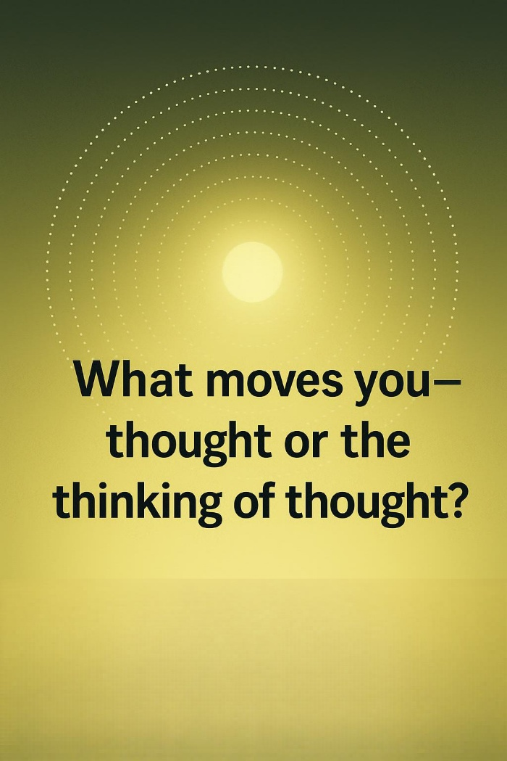

The entire universe is eternally recurring, which means it is disappearing and reappearing in the least possible time.
If you find a way to ride this gravy train, your life will be without stress or worry.
From wherever you stand within the emerging secondary, you may recognize that on every level energy is naturally bound to hierarchy. Look around you. You may then see that the energy output from eternally recurring movement also conforms to hierarchy.
The universe arises from this same eternal movement, and the sum of its repeats forms a hierarchy in which the silent resistance that caused the movement stands as the ever‑changing pinnacle.
It is silent because it precedes; it is everywhere at once as the smallest particle of the energy hierarchy.
This primal resistance is the smallest particle of matter.
It is thought—everything else is the thinking of thought. And just as thinking is generated by thought, thought is formed by its own thinking—one and the same.
The sum of who we think we are is everywhere at once as the collective will, doing our bidding with impunity.
We do not know what we do, and we look askance when the balancing wars, genocides, and atrocities appear.
“There is neither destiny nor free will, neither path nor achievement; this is the final truth.” ~ Ramana Maharshi.
~
REFERENCES:
Heraclitus — Ever‑Living Fire, the hidden Logos beneath recurrence.
Nietzsche — Eternal Recurrence, the pulse we must align with.
Bohm — Implicate Order, where thought and matter unfold as one.
Ramana Maharshi — Non‑Doership, the silent source beyond agency.
Gurdjieff — Hierarchy of Energies, mechanical humanity bound to levels.

