THE HUMAN FELLOWSHIP

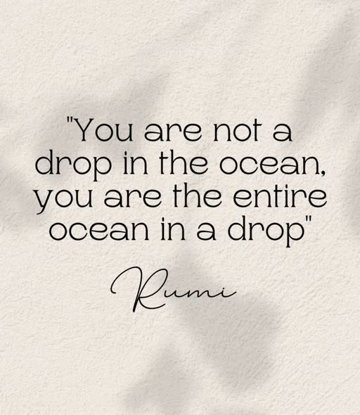

All of life is centered on the same eternally recurring movement.
Every recurrence rises as a wave, filling a collective ocean.
"You, yourself, are the eternal energy which appears as this Universe. You didn't come into this world; you came out of it. Like a wave from the ocean." - Alan Watts.
Each wave carries a gathering mind, yet the mind of the ocean gathers all as its own.
This is the rule of ascendancy - the natural patterning.
The universe is a construct, a machine, a generator: the same eternal rotation producing its output.
The difference between ordinary generators and the eternal generator is that the eternal generator is limitless - eternally grounded.
The universe is the secondary result of one eternal movement repeating to the demand of thinking.
The resistance that initiated the movement is thought.
The individuals that emerge are unaware that they merge into a body of thought with a will of its own, everywhere at once.
The sum of thinking becomes the mind of man.
The parts cannot perceive this because the silent thought precedes each turn of the eternal wheel.
It is the hidden coherence before the visible world.
The parts cannot perceive the whole because the silent thought is everywhere at once as the smallest movement, the smallest particle.
It is cause before effect.
Humanity is challenged to overcome individuality and reconcile the ocean to itself - to recognize its complicity in the whole.
"The whole is more than the sum of its parts." -Aristotle.
The oceanic form is an emergent principle — the sum of our parts, hidden within the individual mindsets of humanity.
We are a twisted thought, and the sum of our thinking, as one, is the most dangerous and careless force on earth — everywhere at once, listening to every conversation, integral to all events, great and small.
It is a monster that perfectly reflects the sum of who we think we are in every passing moment.
We change and it changes accordingly.
We are one and the same - unavoidable.
REFERENCES:
Alan Watts — The Book: On the Taboo Against Knowing Who You Are (wave–ocean identity; emergence from the world)
Aristotle — Metaphysics (the whole exceeding the sum of its parts; emergent form)
Heraclitus — fragments on the ever-living fire and the unity of opposites (eternal movement)
Plotinus — Enneads (the One as source; emanation; the many returning to the whole)
C.G. Jung — collective unconscious and emergent psychic totality (the gathering mind)
David Bohm — implicate order (the whole preceding the parts; hidden coherence)
Hannah Arendt — mass behavior and the automatic machinery of collective will (the monster made of thought)

