THE JOKER'S WILD

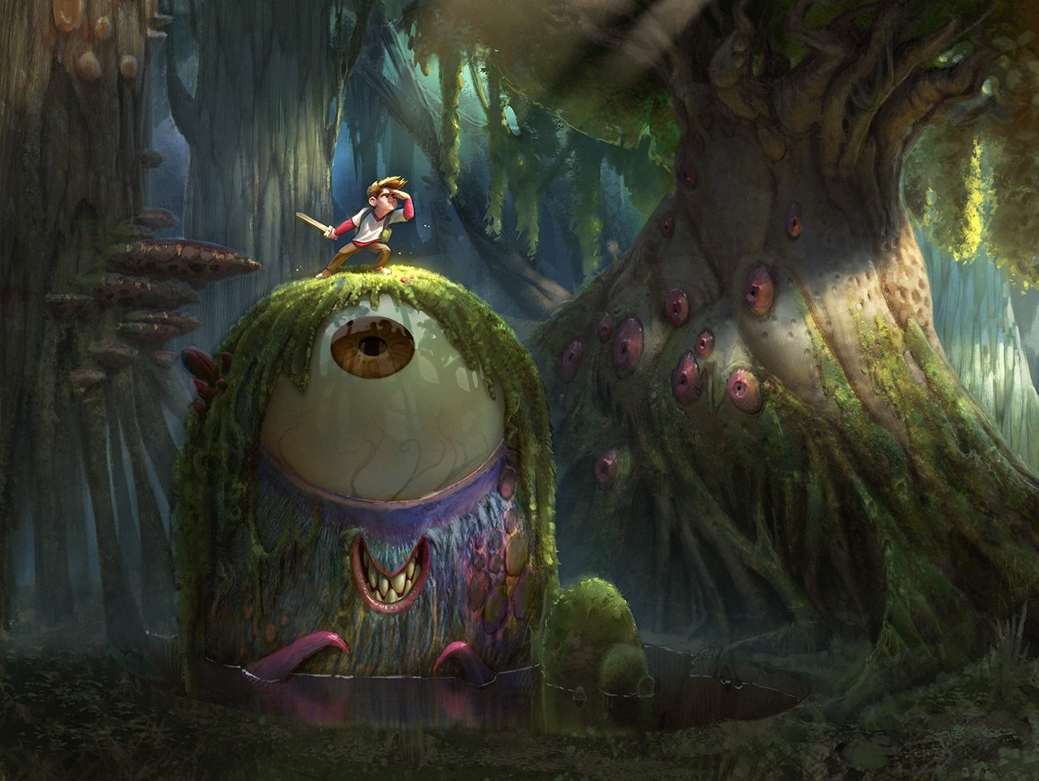

The universe has 8.3 billion cards and collecting more as it goes.
Within the fold is a wild card.
The Joker's wild and can make up any hand as it goes.
~
The universe began when all as one we twisted from Eternity.
The growing tension entered critical mass before snapping back to eternal reality.
This movement is the core of life:
Discovered by Isaac Newton, measured by Max Planck, and harnessed by Nikola tesla to light up the world - yet never fully understood, because a Joker sits in the works, pulling every string.
"We seek him here, we seek him there,
Those Frenchies seek him everywhere.
Is he in heaven? — Is he in hell?
That damned, elusive Pimpernel." - The Scarlet Pimpernel.
~
To establish the presence of the 'Pimpernel' one must return to the highlighted truth above.
Movement is energy - and energy is illusion.
The illusion returns to itself when play stops being fun - when the twist folds back under its own natural tension.
Now, and most importantly, it must be recognized that the twist of movement was caused by resistance to Eternity - all as one.
It follows that the cause of the movement is silent within its effect - cause and effect, one and the same except one does not recognize the other.
The movement recurs eternally for one purpose: to find its cause and bring it home.
This is the simple purpose of life, made difficult by the silent principal that is everywhere at once within the mass of its own output.
Its superiority is revealed in this: we do not even know the universe is eternally recurring.
This is the Achilles heel of the demon in our heads.
The sum of our own thinking is aligned against the knowledge that will collapse the illusion:
Awareness of the eternally recurring universe is anathema.
We are as children refusing to come home even though it is happening anyway.
~
REFERENCES:
Plotinus — The Enneads: the One appearing as many, the source hidden within its emanations.
Parmenides — On Nature: motion and change as illusion; only the One is real.
The Upanishads: the world as Maya, the One disguising itself as multiplicity.
David Bohm — Wholeness and the Implicate Order: a hidden order beneath all apparent fragmentation and movement.
Nietzsche — Eternal Recurrence: existence looping until the self recognizes its origin.
Mircea Eliade — The Myth of the Eternal Return: all cycles aiming to return to the beginning, the source.
Kabbalah — Tzimtzum: separation arising from a contraction away from the Infinite.
Gnostic cosmology (Sophia myth): a fall from unity creating a world estranged from its source.
Lewis Hyde — Trickster Makes This World: the trickster as the hidden disruptor shaping reality.
Paul Radin — The Trickster: the archetypal Joker — elusive, boundary‑breaking, self‑concealing.
.
.
.
Picture: The Scarlet Pimpernel.

