THE LORD FOOL

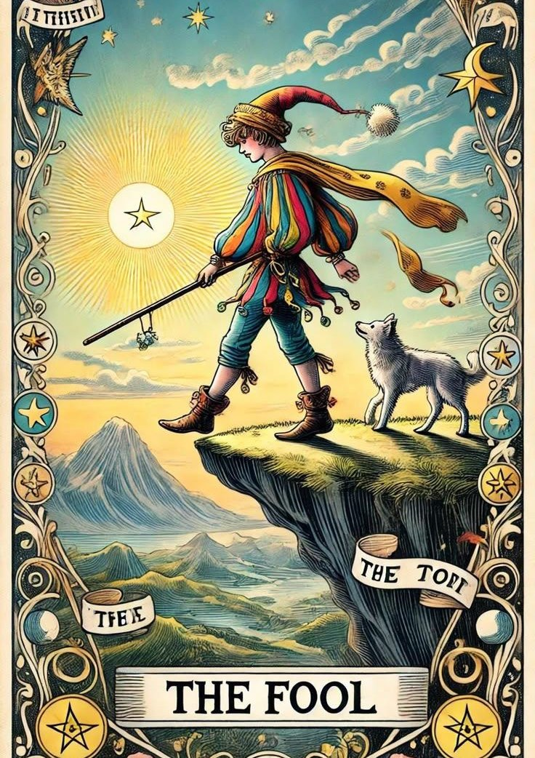

The entire thinking of humanity in every moment is held inside one thought— a thought everywhere at once, ensuring we never question its existence.
This thought is the resistance that turned eternity inside out for an instant of time:
One twisted into all, all compressed into one—
a point of view, a brief spark of energy destined to be extinguished.
As the eternal twist recurs, thought hides within the shadows of its own resistance—
the shadows we call time.
And as long as the shadows do not know they are being manipulated,
the silent one remains in control.
“Know that this house can be useful only to those who have recognized their (eternal) nothingness and who believe in the possibility of changing.”
— G. I. Gurdjieff, Views from the Real World.
And so begins the slow demise of the lord fool within each of us.
~
REFERENCES:
The Tao Te Ching — Chapters 1, 16, 25 The nameless, silent origin that shapes all things without being noticed.
David Bohm — Thought as a System.
Thought creates the world it then forgets it created.
A direct parallel to “thought hiding in its own shadows."
J. Krishnamurti — “The observer is the observed.”
The collapse of the separate point of view.
The Upanishads — Chandogya & Brihadaranyaka.
The infinite folding into the apparent individual self - “eternity turned inside out.”
Thomas Metzinger — The Ego Tunnel.
A scientific dismantling of the “point of view” illusion.
Carl Jung — The Shadow.
The unseen force shaping behavior until brought to awareness.
A clean mirror of the “silent one” and “shadows of time.”
U2 — “If you want to kiss the sky, better learn how to kneel.”
A cultural, accessible expression of surrendering the false self.
A modern echo of the demise of the lord fool.
Hannah Arendt — The Life of the Mind.
Thinking as an invisible force shaping action.
David Eagleman — Incognito
A modern, accessible take on the hidden machinery beneath conscious thought.

